22) Segment Trees –
1) Intro to Segment Trees : -
1.1) Creating a Segment Tree -
2) Performing QUeries in Segment Trees -
3) Update on any index in Segment Tree -
4) Max Segment Tree - in particular given range -
4.1) Creation & Query in Max Segment Tree -
4.2) Update in Range Max Segment Tree - in particular given range -
5) Range Min Segment Tree - Creation, Query & Update in particular given range –

1) Intro to Segment Trees : -
/*
- Segment Trees - are used to handle the quns based on Range Queries or Update Queries.
- we have discussesd many optimized approches for solvig Range sum or update eleemnt in array.. then why need to use Segment Trees ?
- Uisng brute force approach the TC's for Query Sum is - O(n) & for update is - O(1)
- while using Optimized Approach(Prefix SUm) the Tc's are - O(1) & O(n), for respective tasks.
- So, using different optimized approaches we get different doifferent TC's for Query or update tasks. One is optimized while other is not.
- So, in this casw we prefer to approach 2(prefix sum) because range queries O(1) need to use frequent, update O(n) only done sometimes.
- simiallry, in the case when Raange queriwes are less O(n) and update queries are more O(1), then we'll use Brute Force Approach.
- and in the cases wehn both having high priority - Range QUeries as well as Update - Then Nede to use SEGMENT TREES whuch having TC - O(logn) for both.
*/
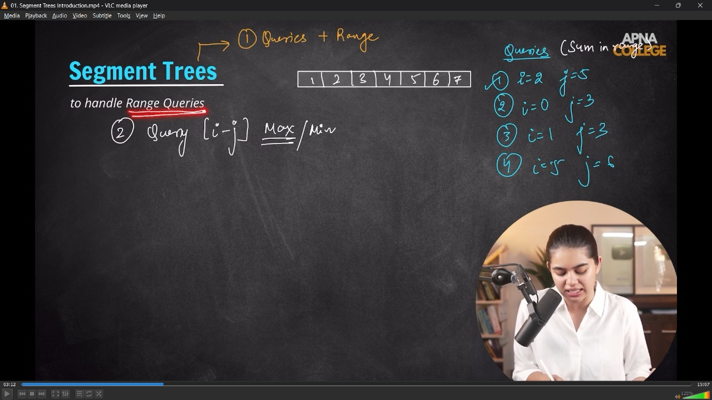
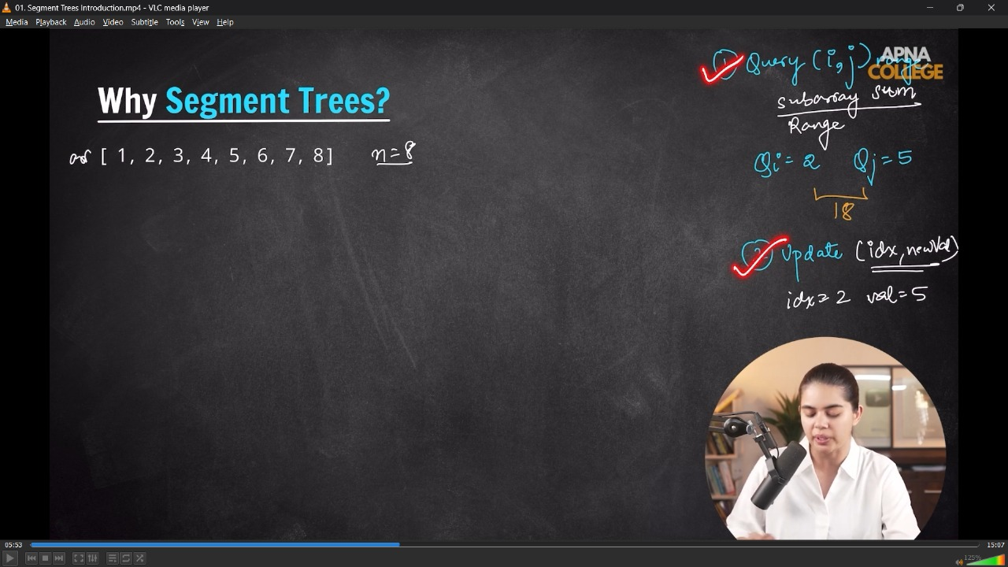
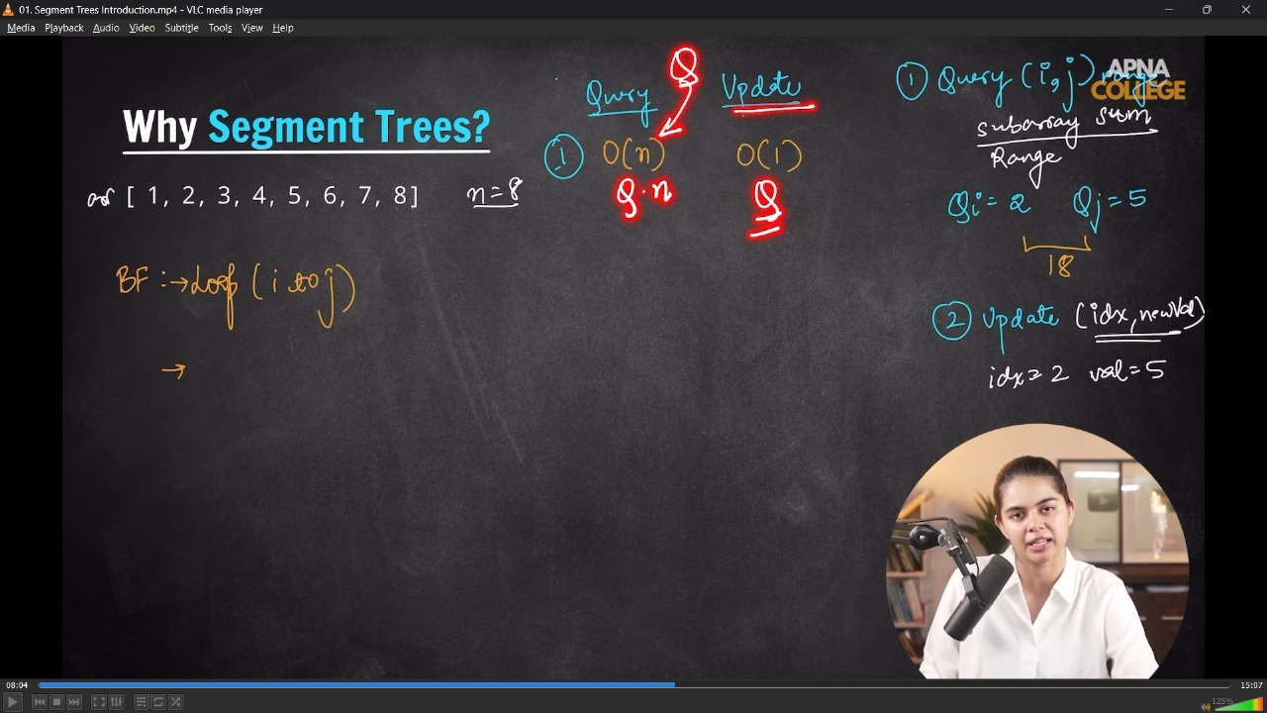
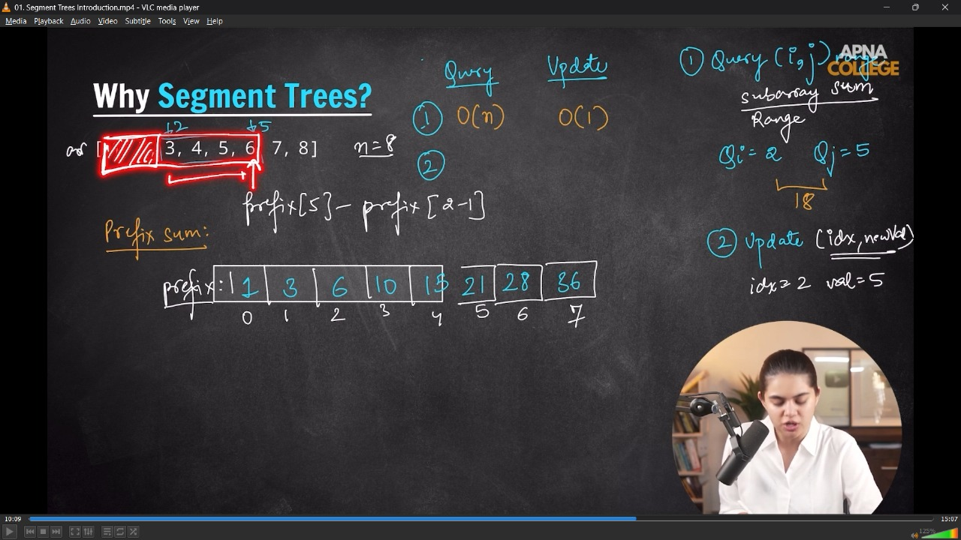
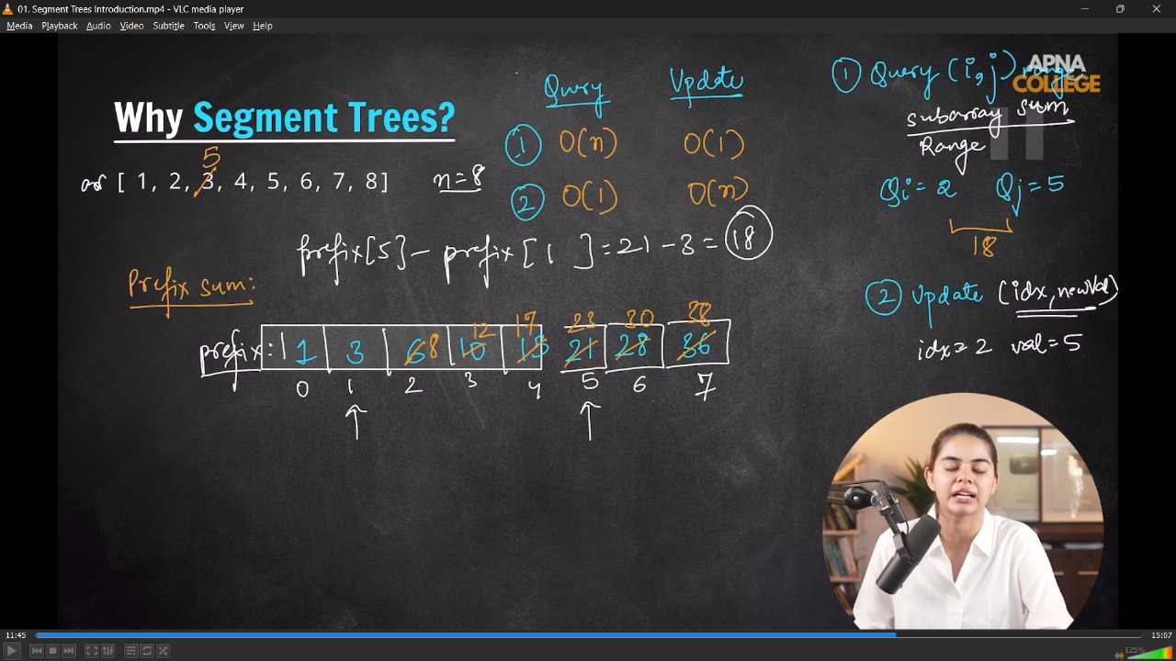
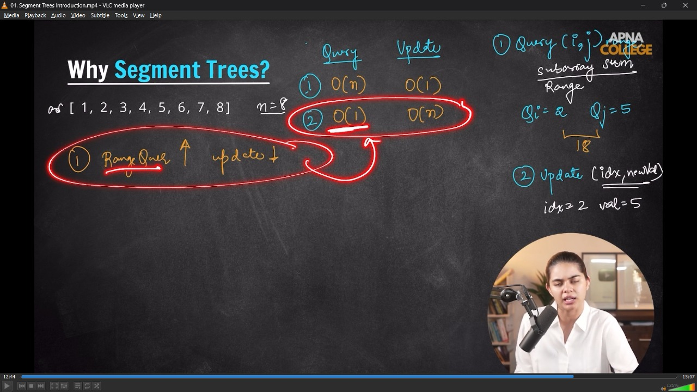
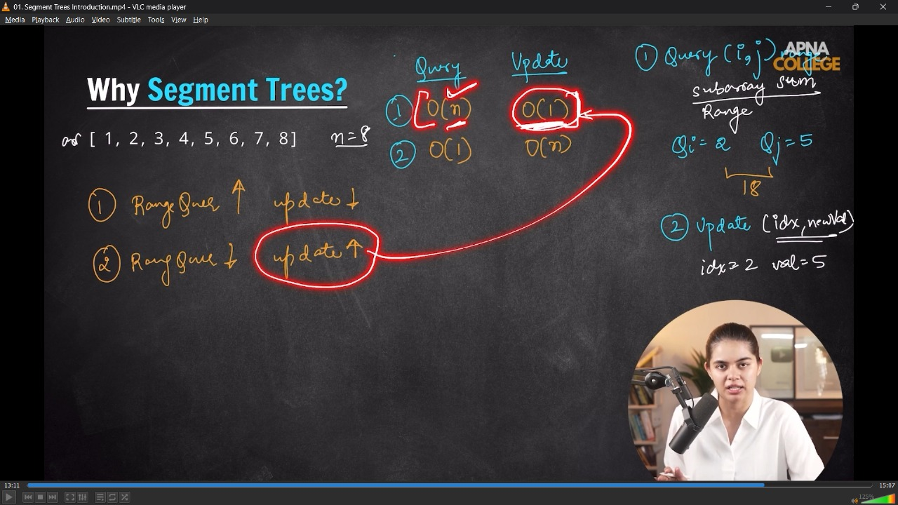
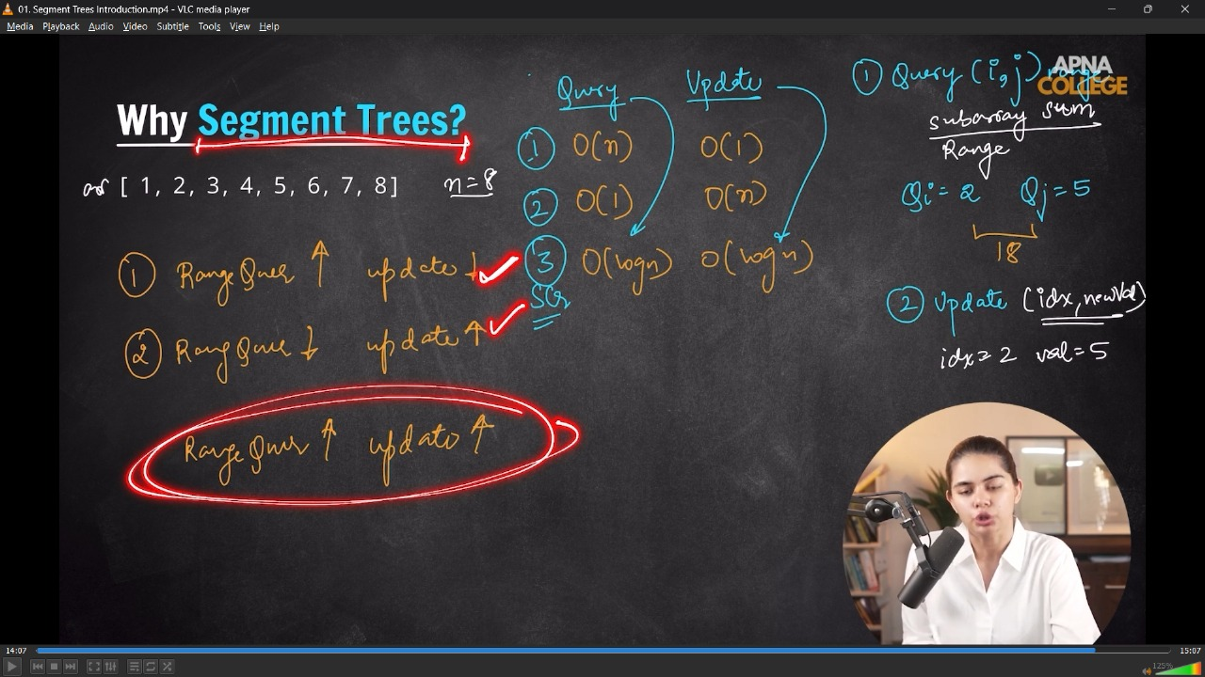
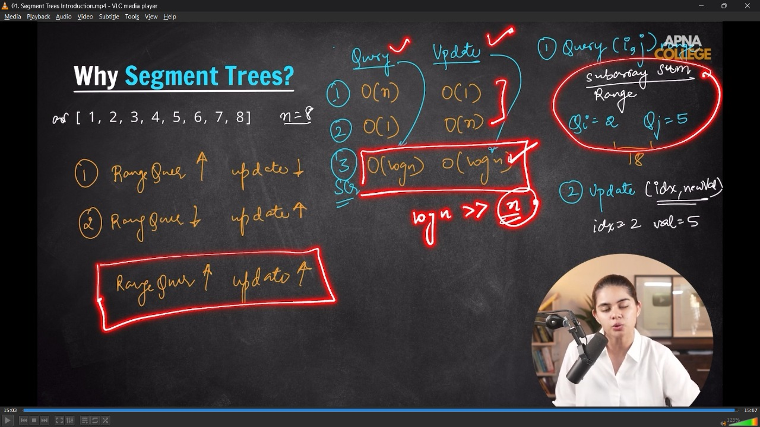
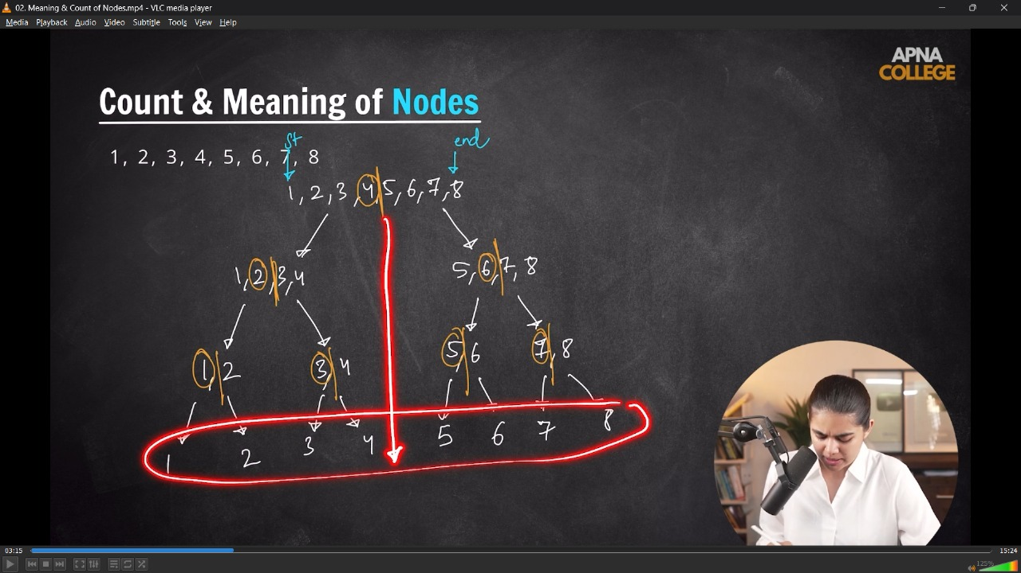
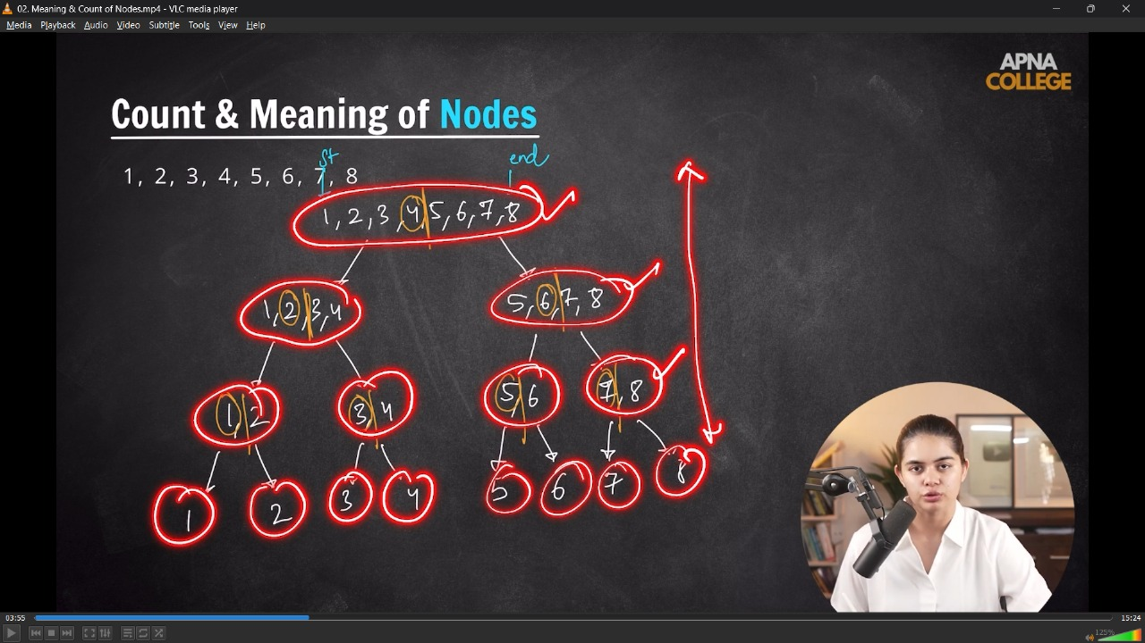
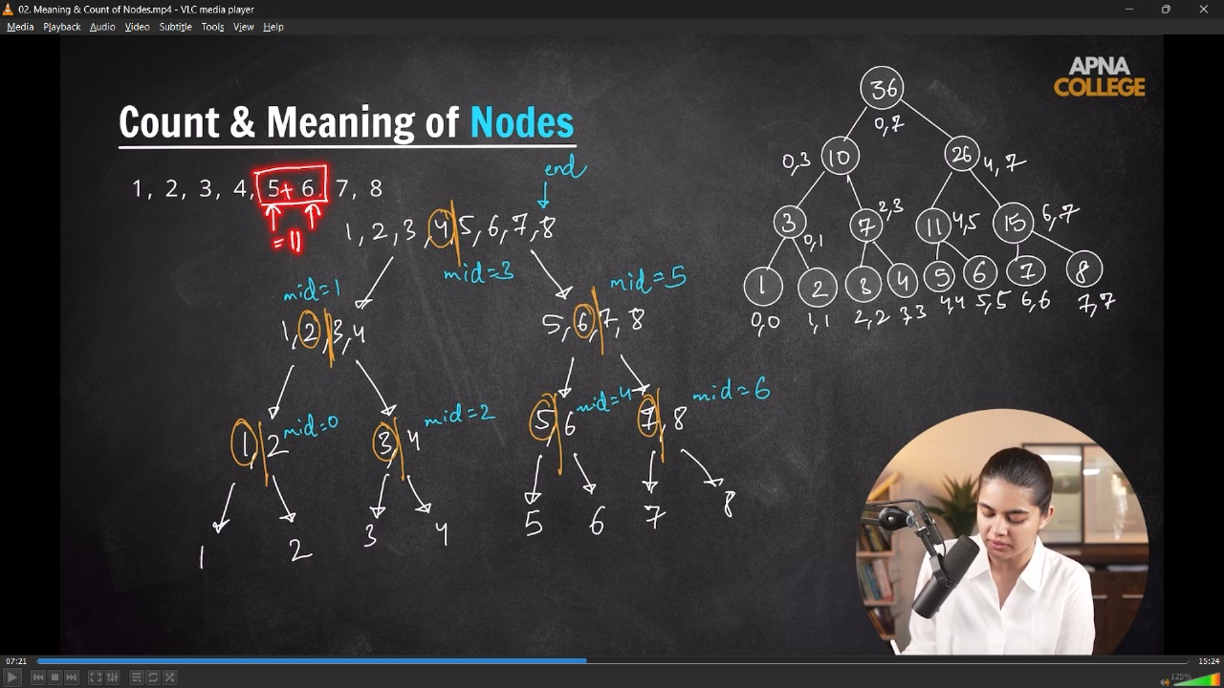
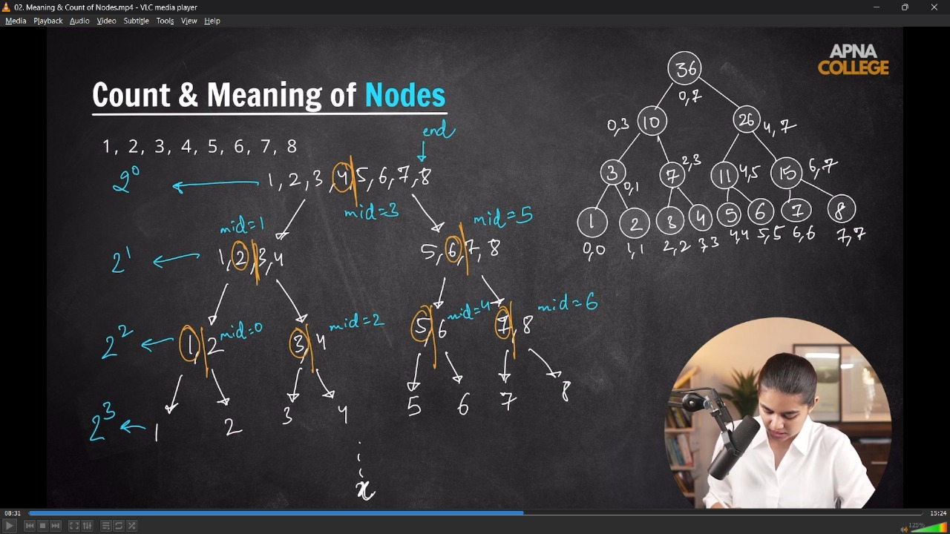
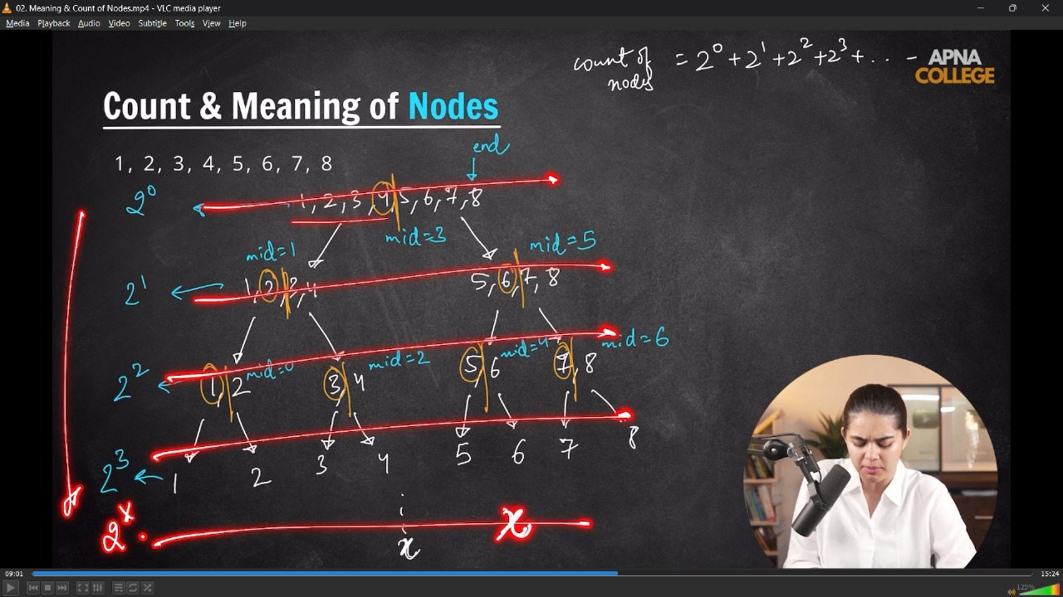
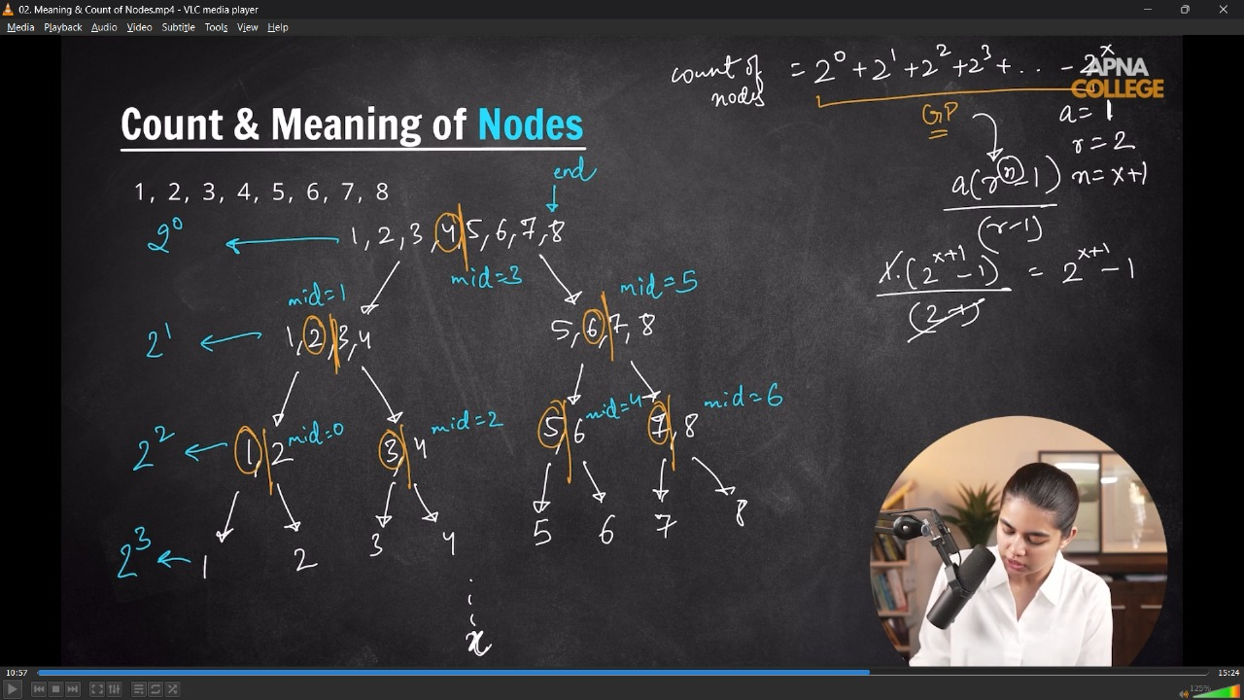
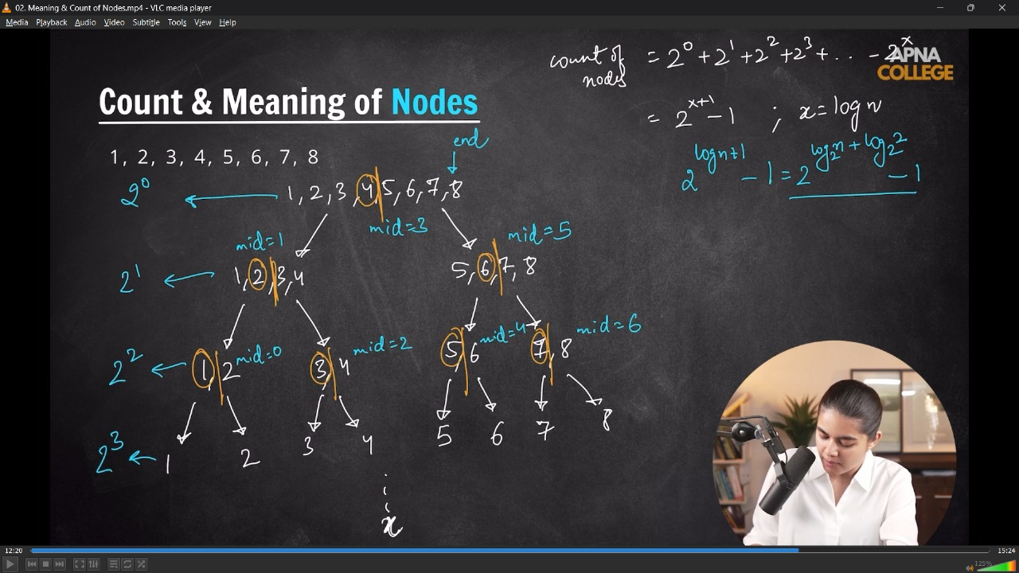
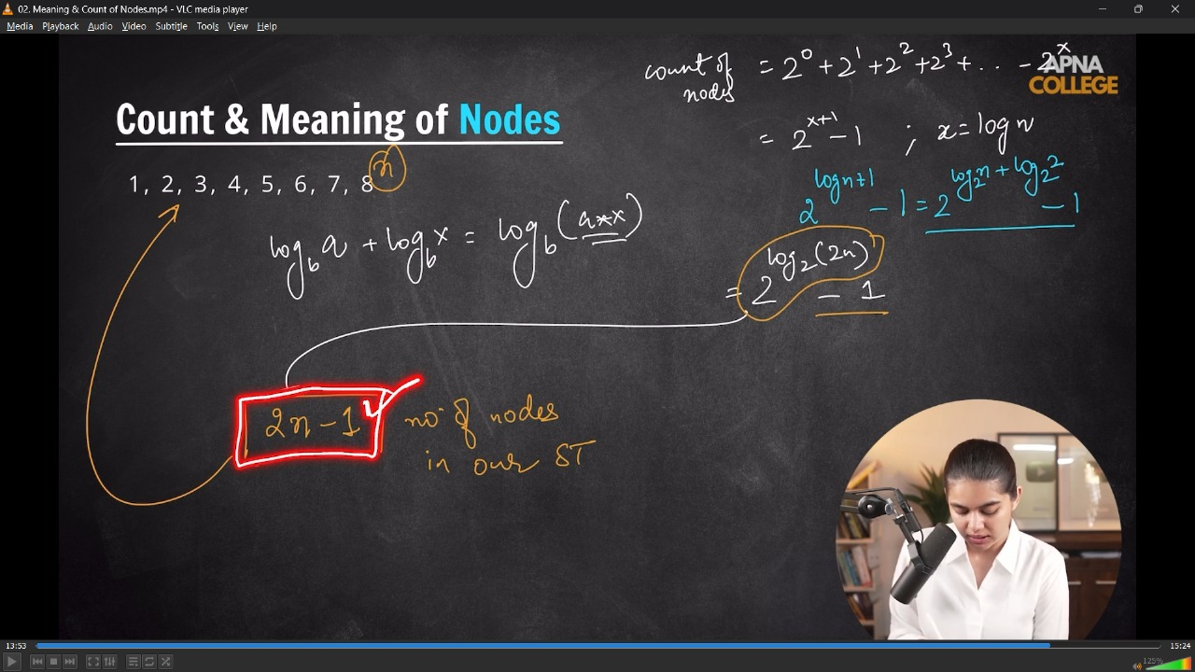
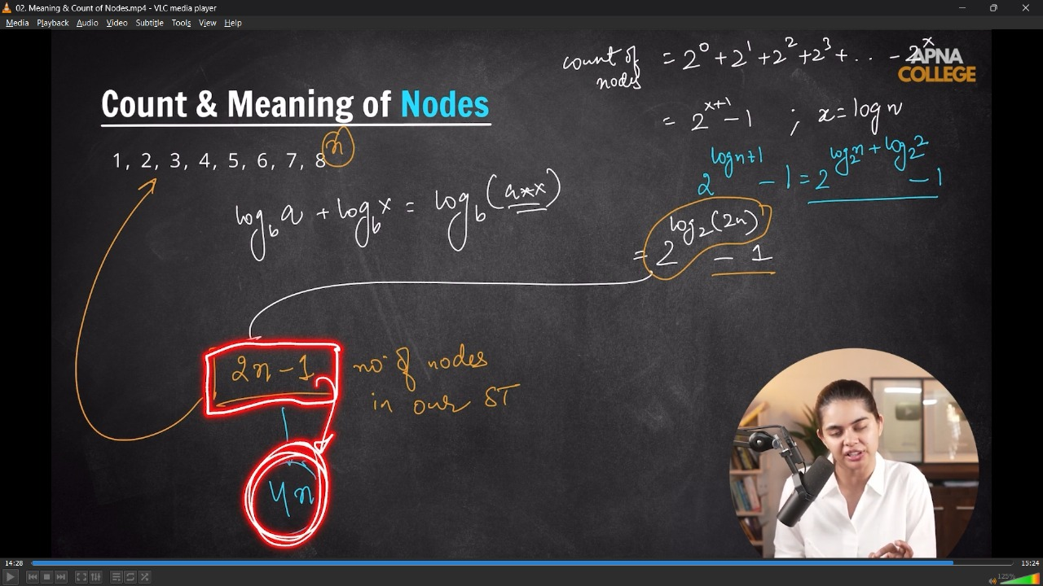
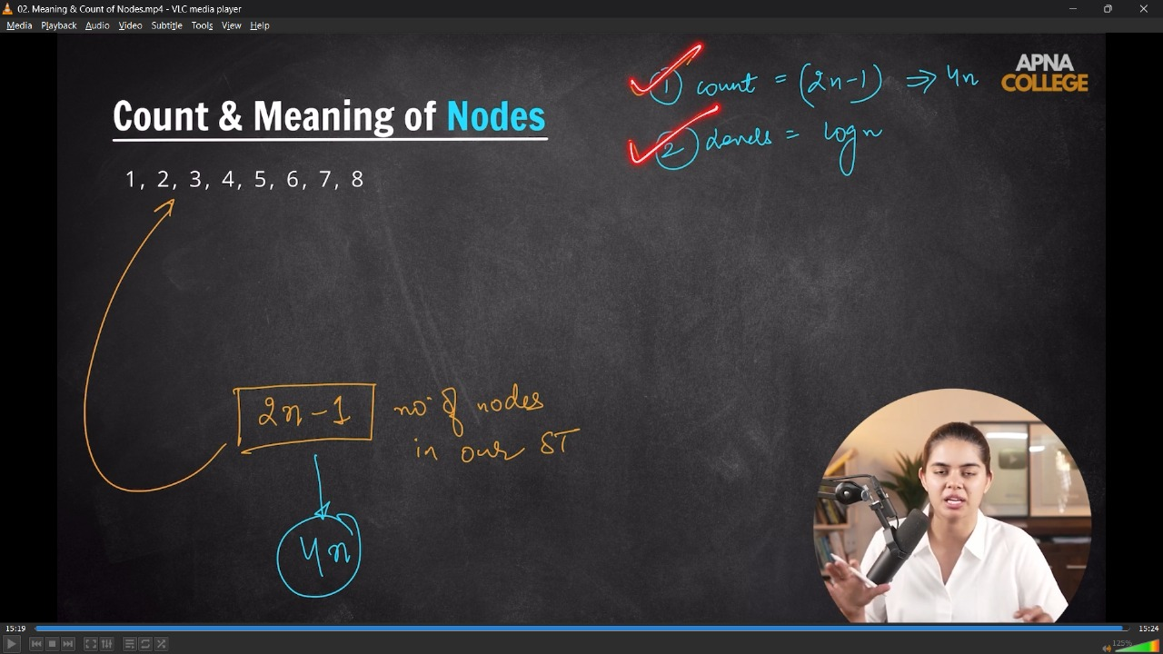
1.1) Creating a Segment Tree -
- If we have an array with n elelments then the Minimum no. of nodes are 2n-1; which is an idle no. of nodes exist in the Segment Trees
- when nnodes in array then Min nodes are - 2n-1, so for avoiding the less nodes we basically takes 4n nodes in Segemnt Trees
- In crearting Segment Tree - the TC will be O(n) but whole using in Query Range or Update operations the TC will be - O(log n) always.
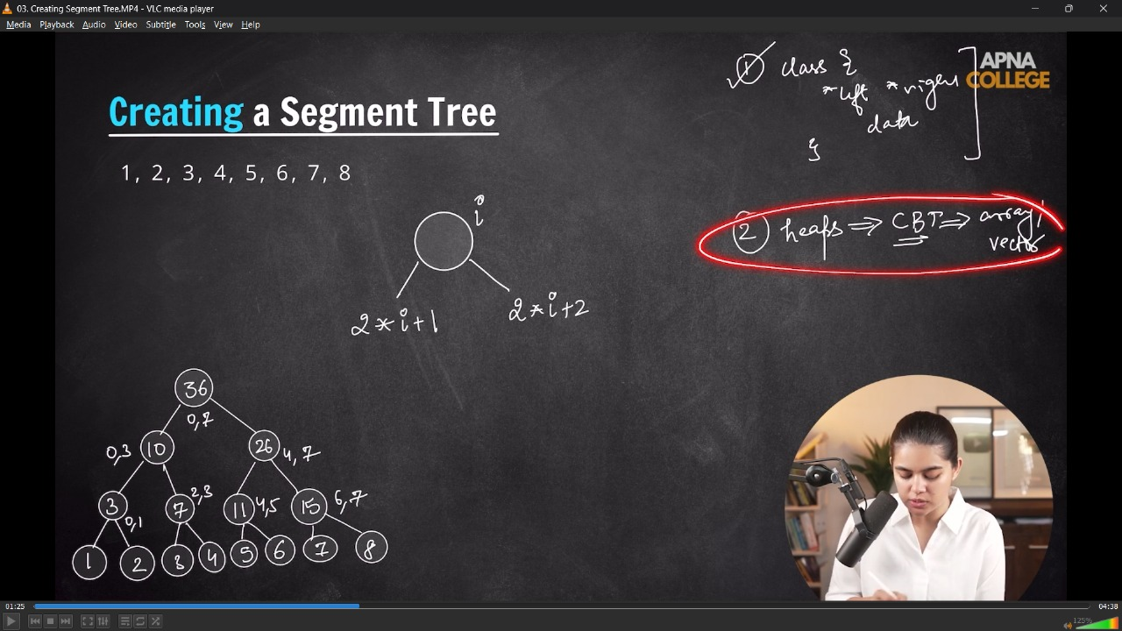
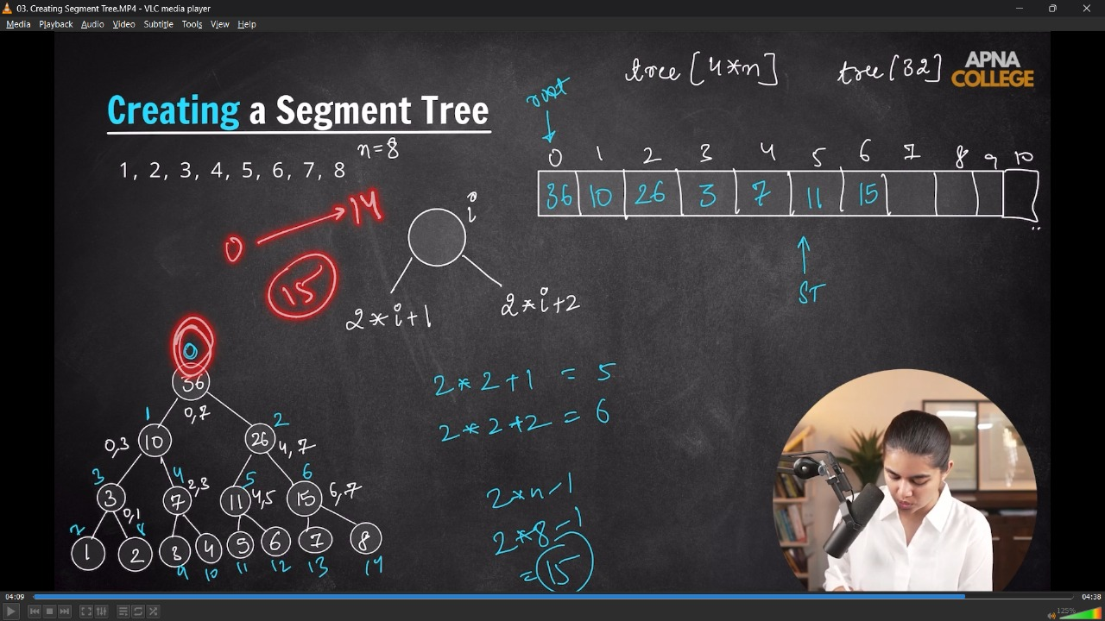
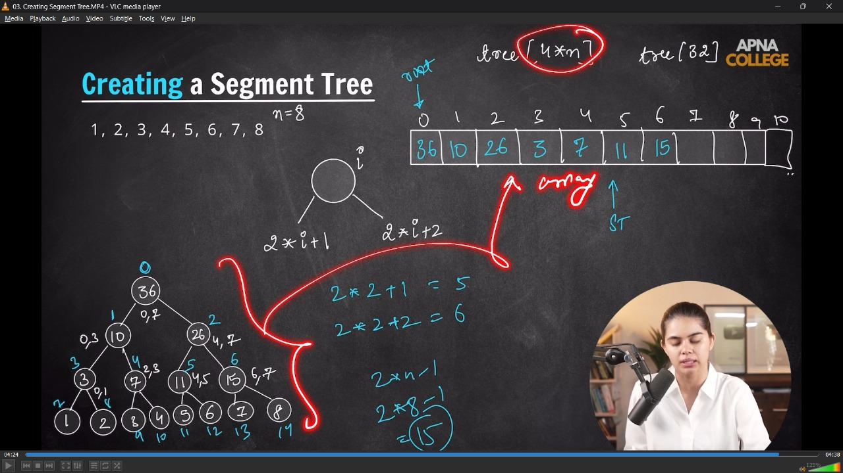
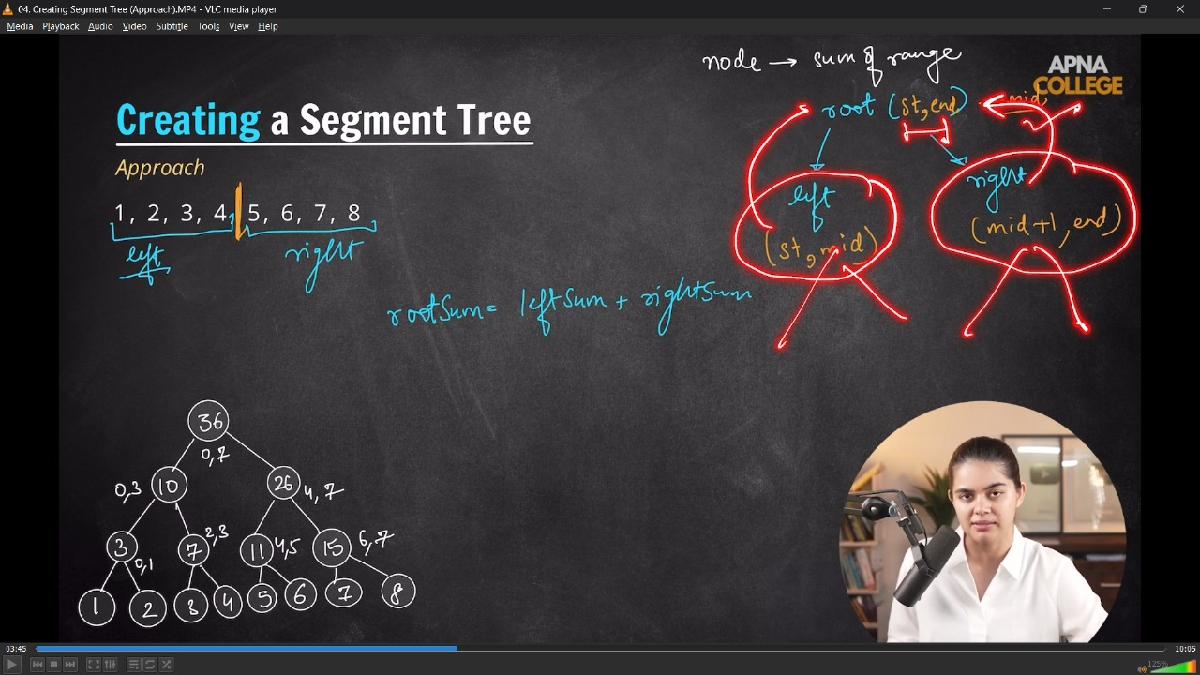
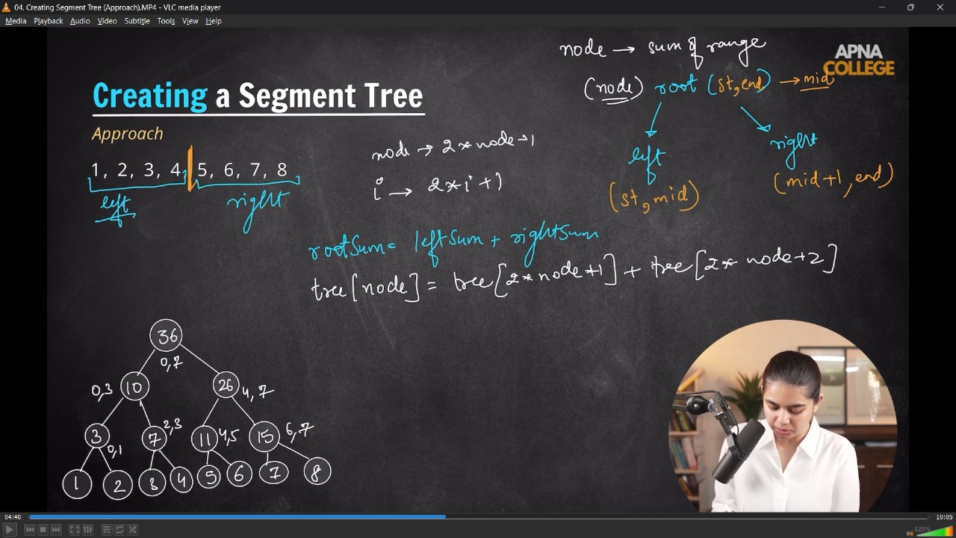
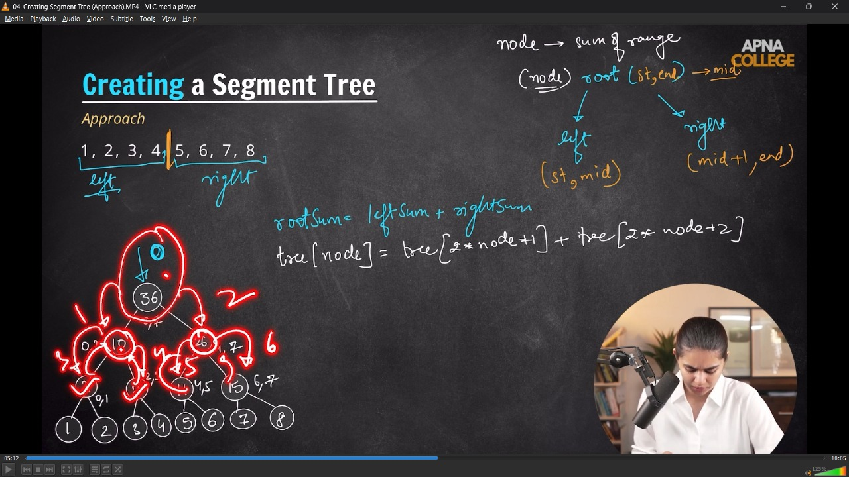
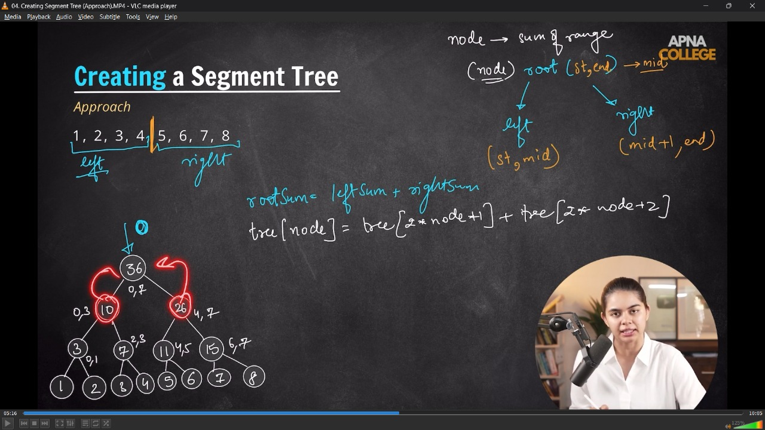
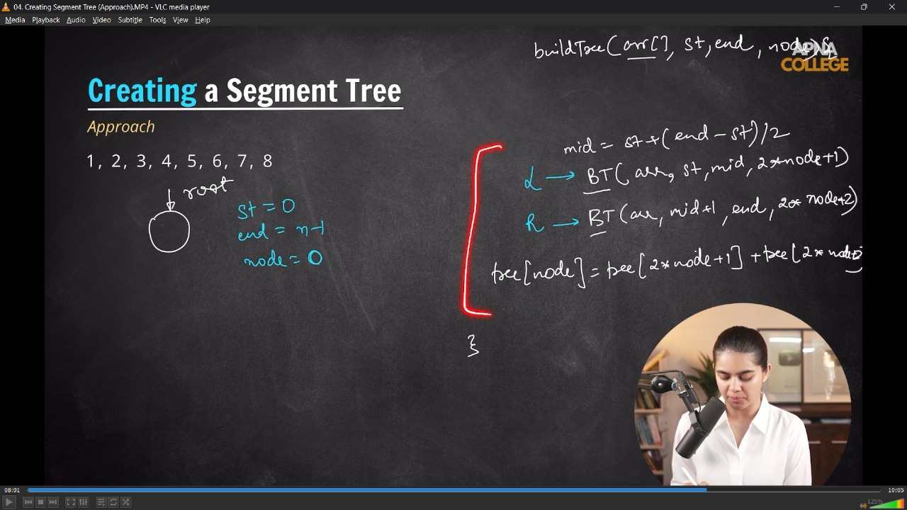
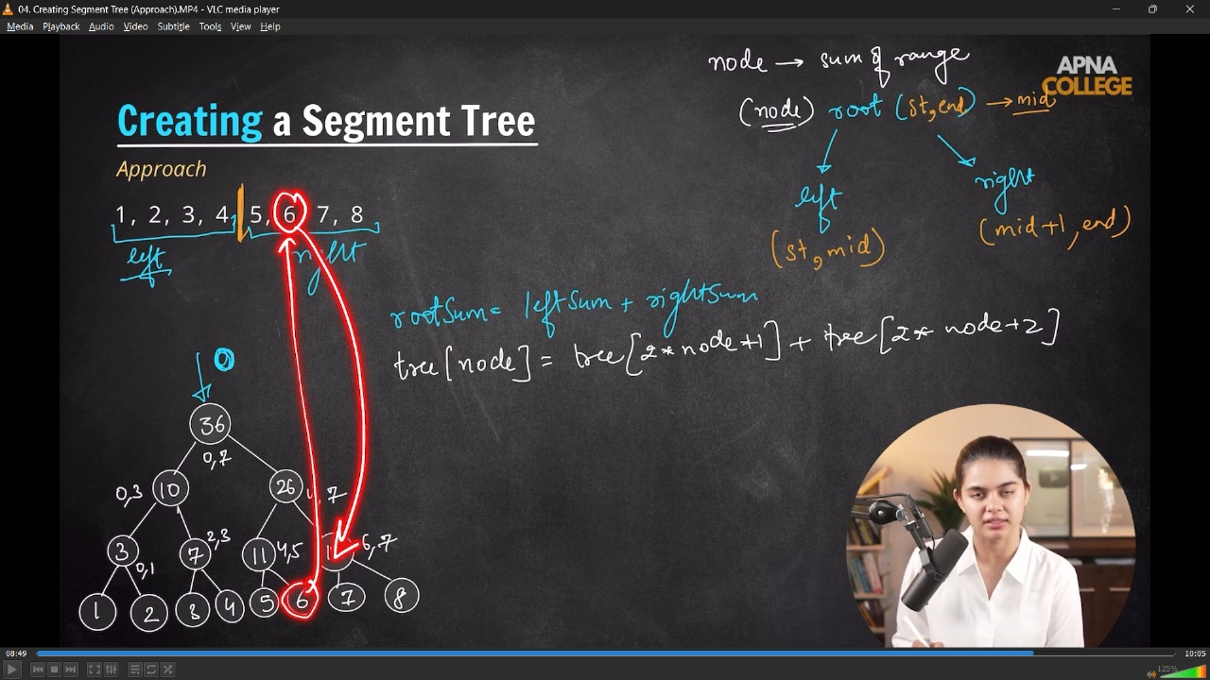
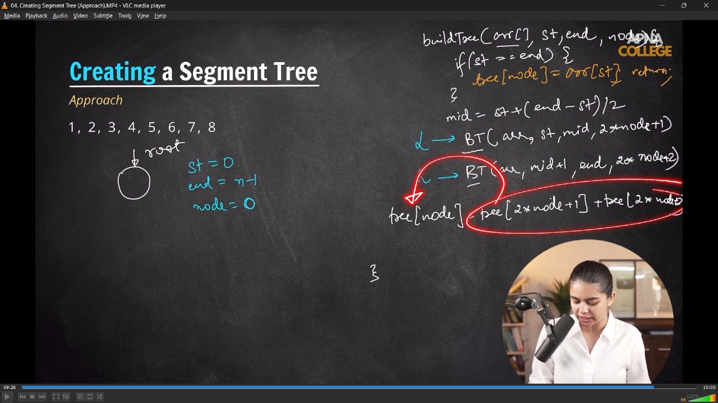
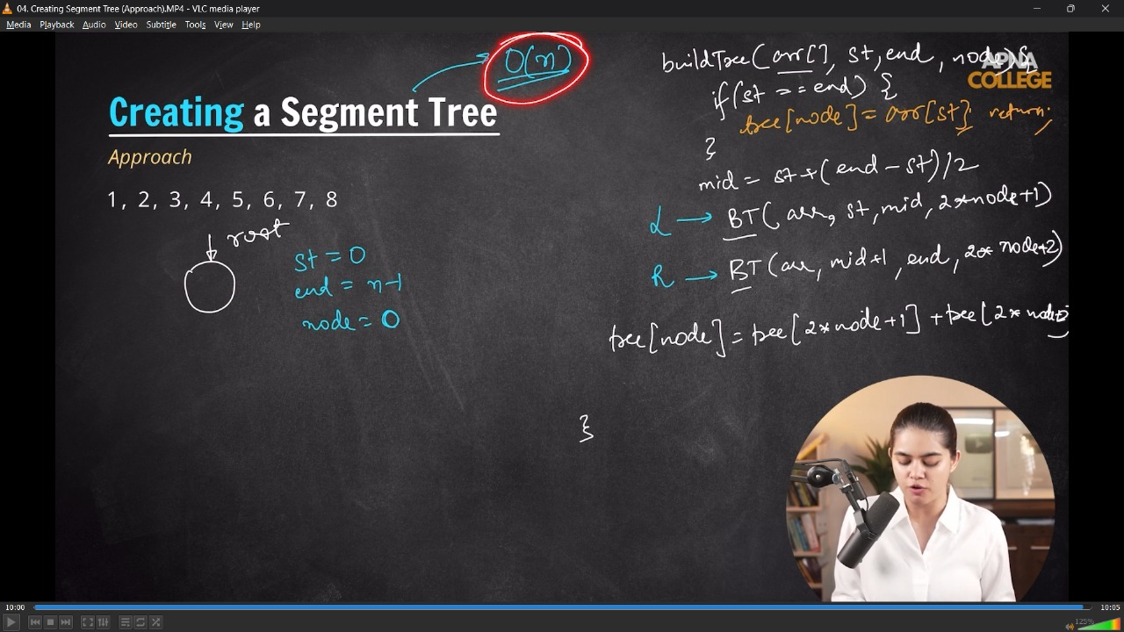

// class SegmentTree
// {
// vector<int> tree; // 4*n
// int n;

// public:
// SegmentTree(vector<int> &arr)
// {
// n = arr.size();
// tree.resize(4 * n);
// buildTree(arr, 0, n - 1, 0);
// }

// void buildTree(vector<int> &arr, int start, int end, int node) // TC - O(n), Nodes - 2n-1;
// {
// if (start == end)
// {
// tree[node] = arr[start];
// return;
// }
// int mid = start + (end - start) / 2;

// buildTree(arr, start, mid, 2 * node + 1); // call for left subtree
// buildTree(arr, mid + 1, end, 2 * node + 2);// call for Right subtree

// tree[node] = tree[2 * node + 1] + tree[2 * node + 2];
// }

// void printTree()
// {
// for (int i = 0; i < tree.size(); i++)
// {
// cout << tree[i] << " ";
// }
// cout << endl;
// }
// };

// int main()
// {
// // Range Sum Queries -
// vector<int> arr = {1, 2, 3, 4, 5, 6, 7, 8};

// SegmentTree st(arr);
// st.printTree();

// /*
// Created Seg,ent Tree Successfully -
// 36 10 26 3 7 11 15 1 2 3 4 5 6 7 8 0 0 0 0 0 0 0 0 0 0 0 0 0 0 0 0 0

// */
// }
// ____________ ____________ ____________ ____________ ____________
2) Performing QUeries in Segment Trees -
/*
- when case of no overlapping - if we need the sum from 2-5 then no need to traverse from 6-7 .
- jb parent(6-7) node pr hi visit krne ki need nhi h to child node pr to krna hi nhi he
*/
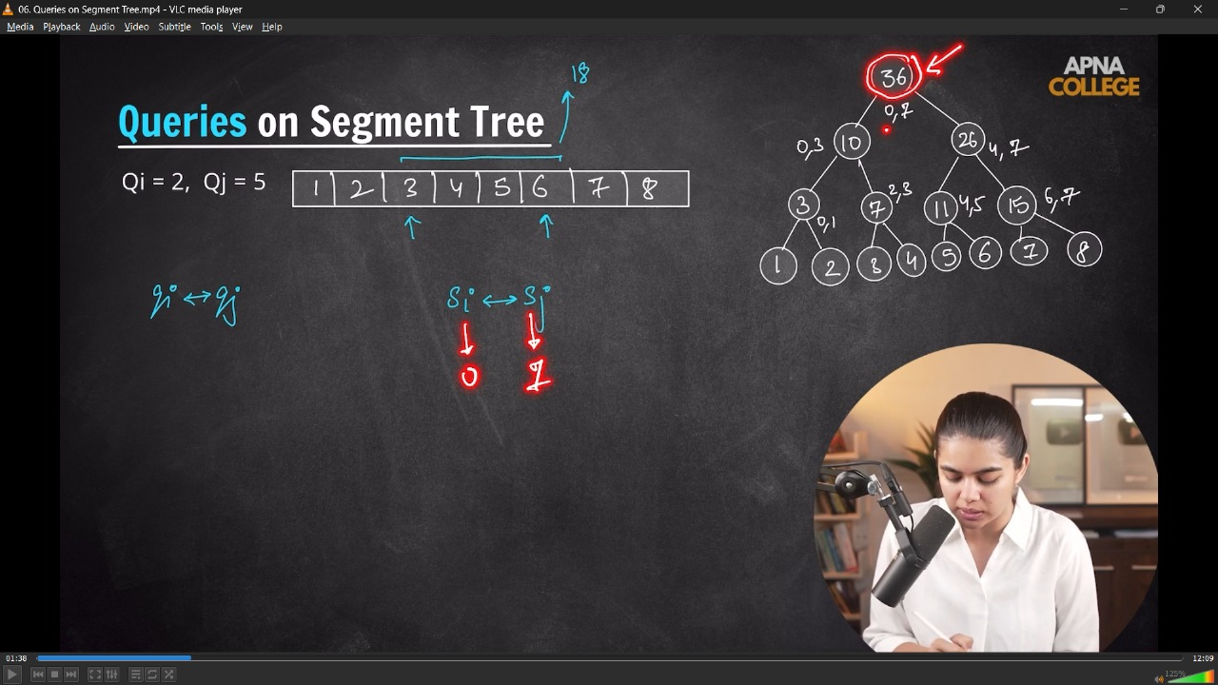
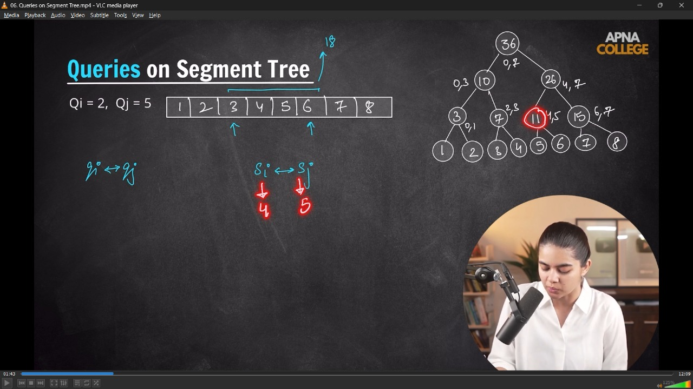
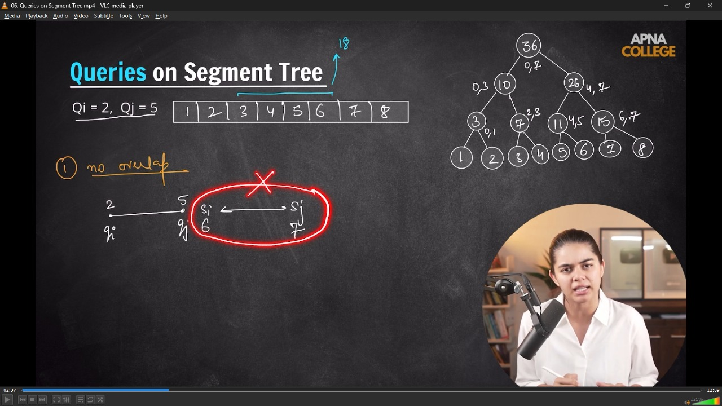
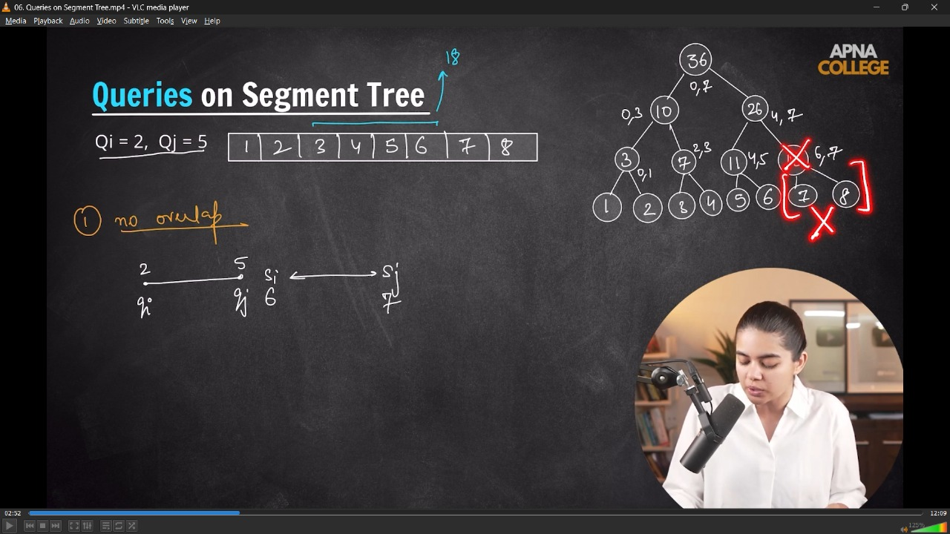
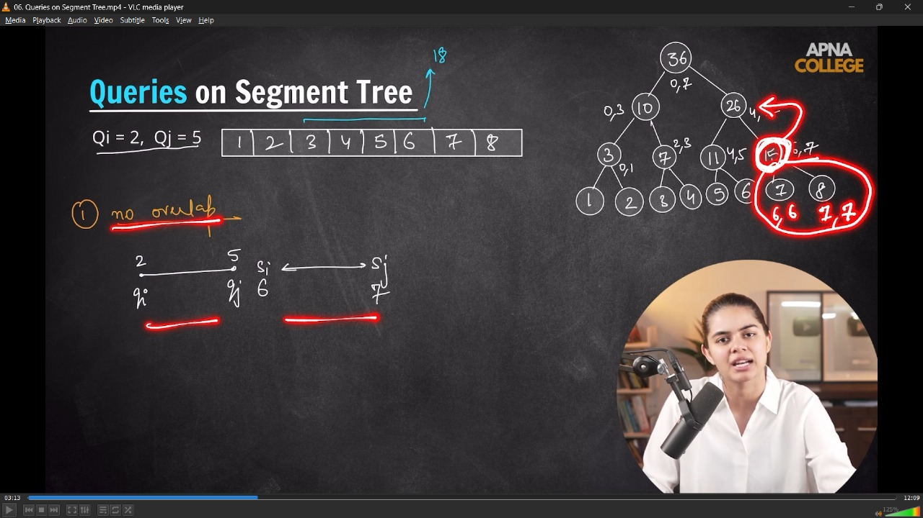
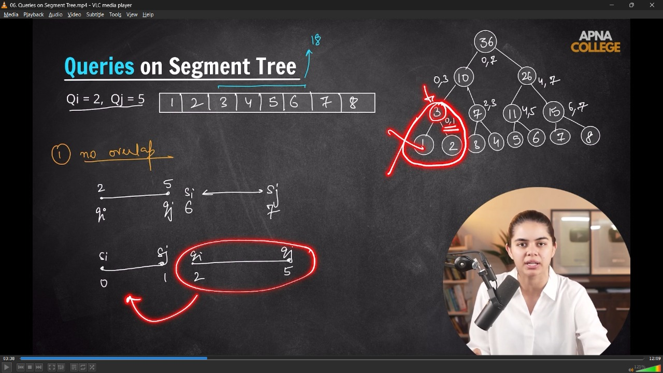
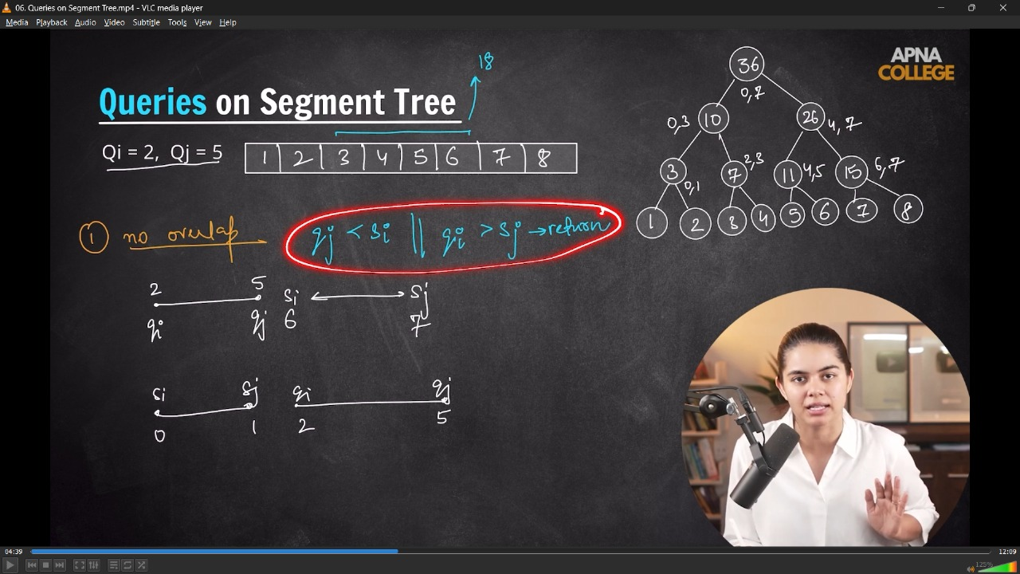
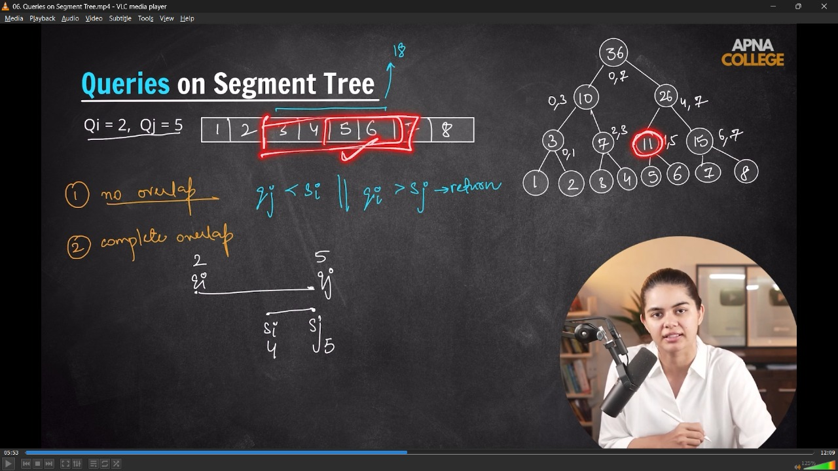
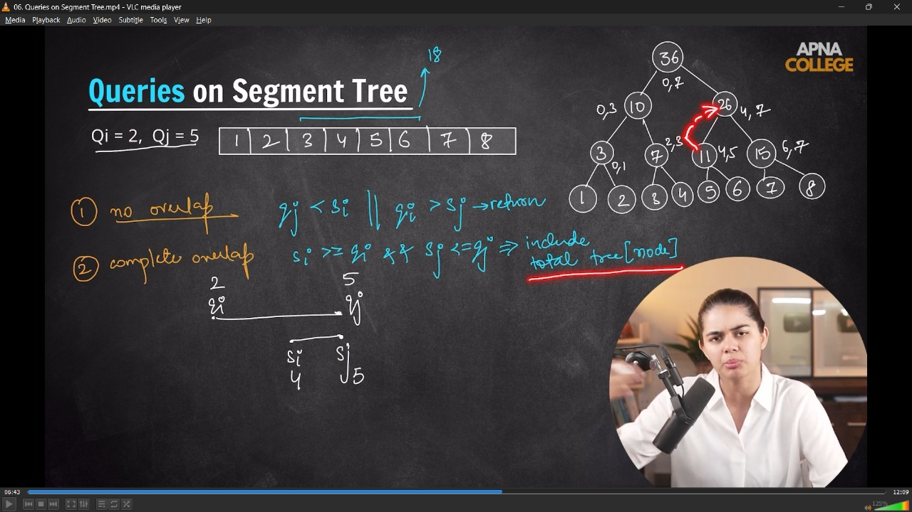
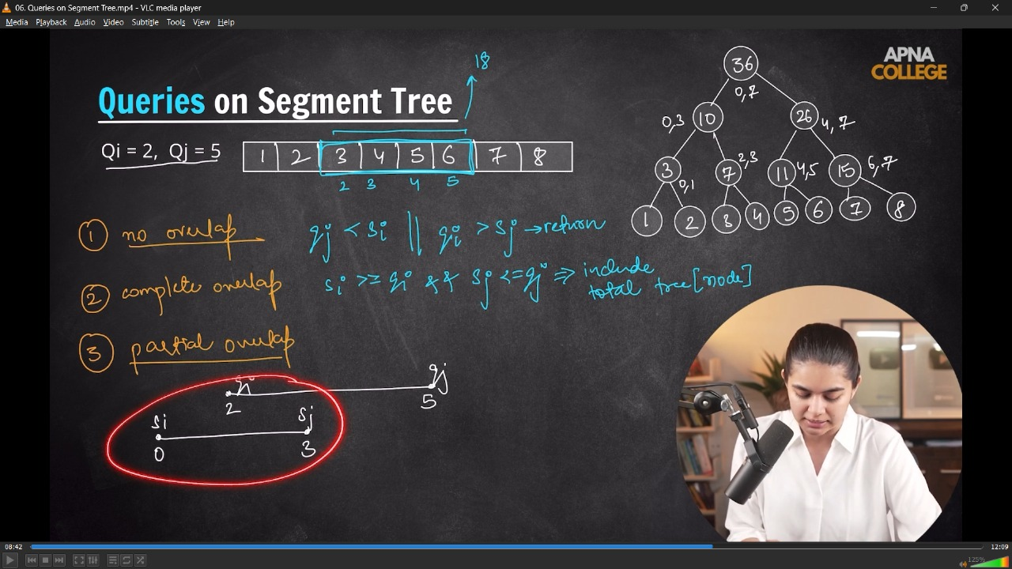
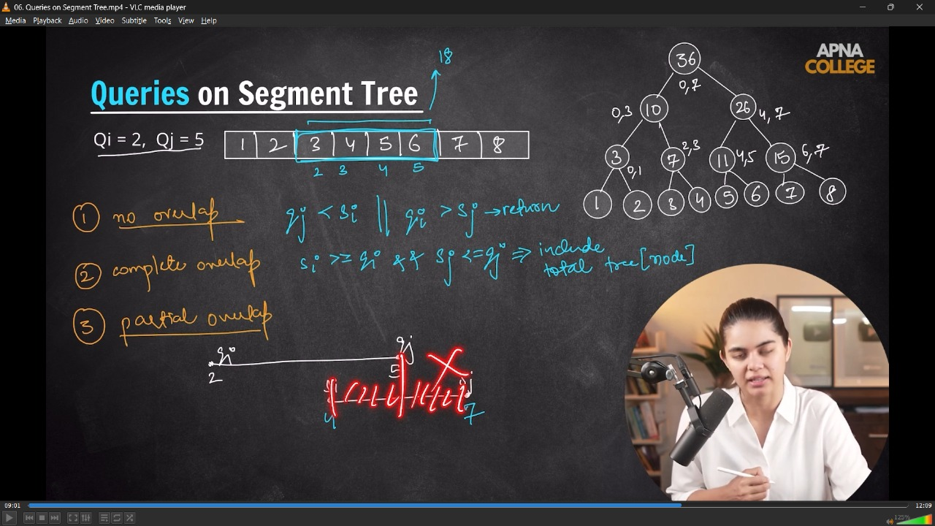
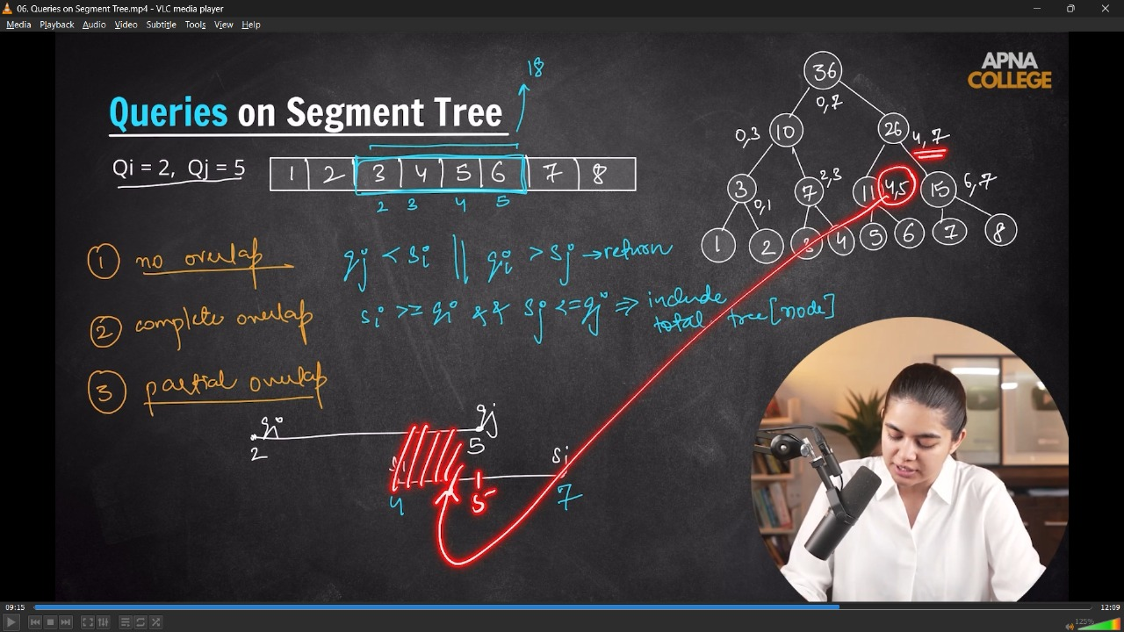
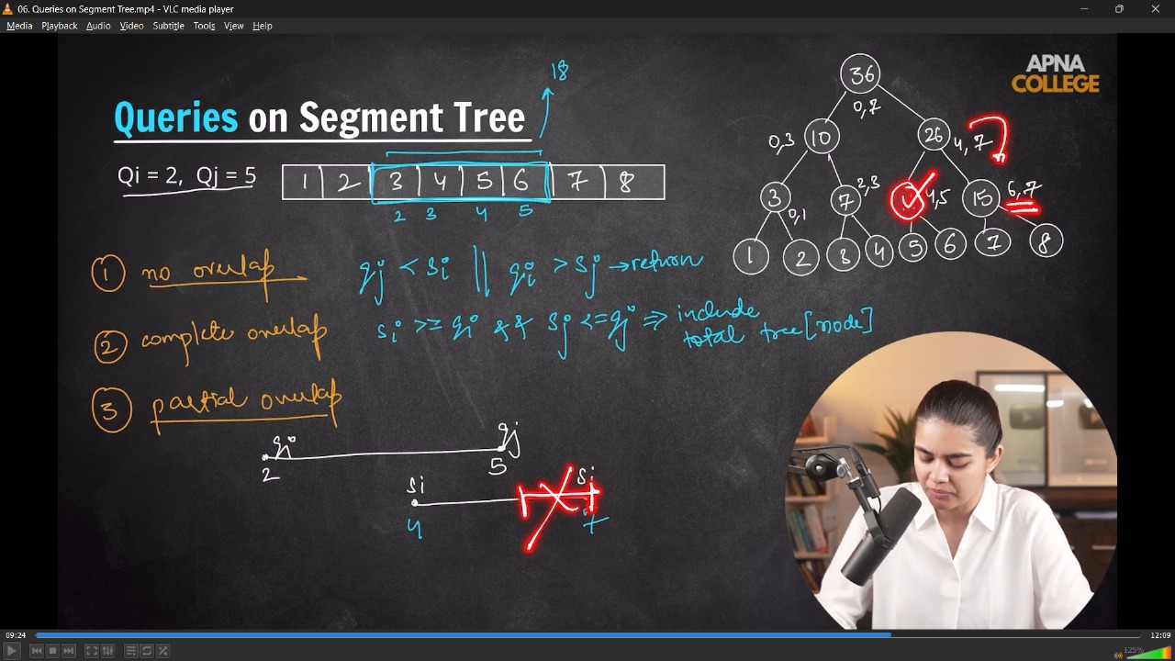
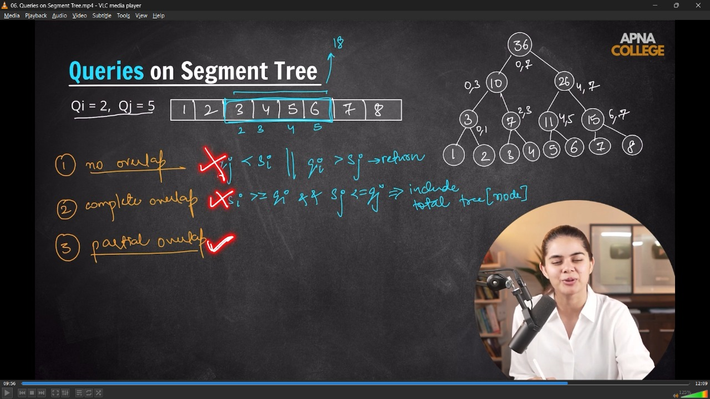
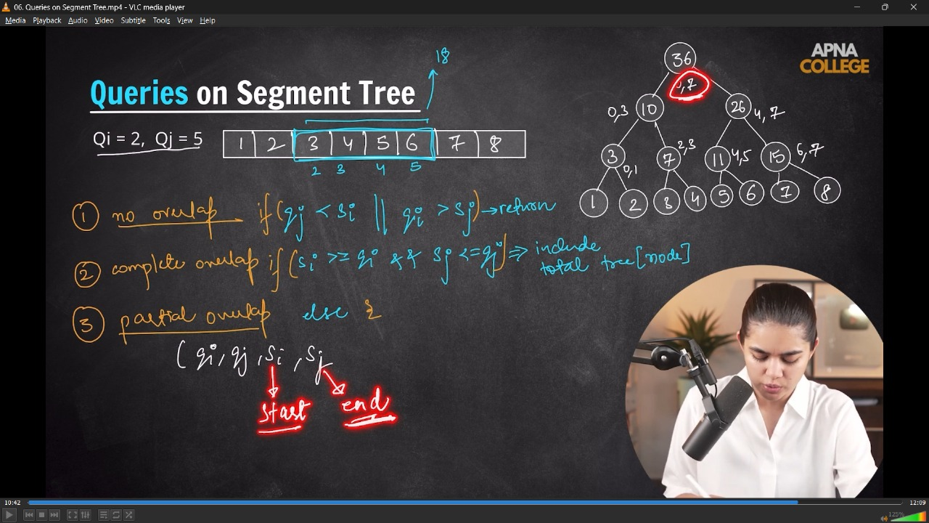
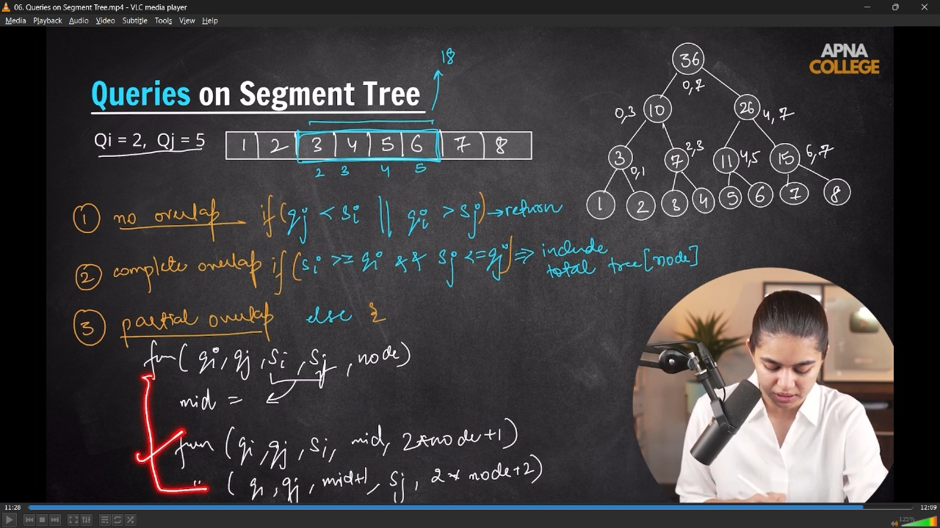
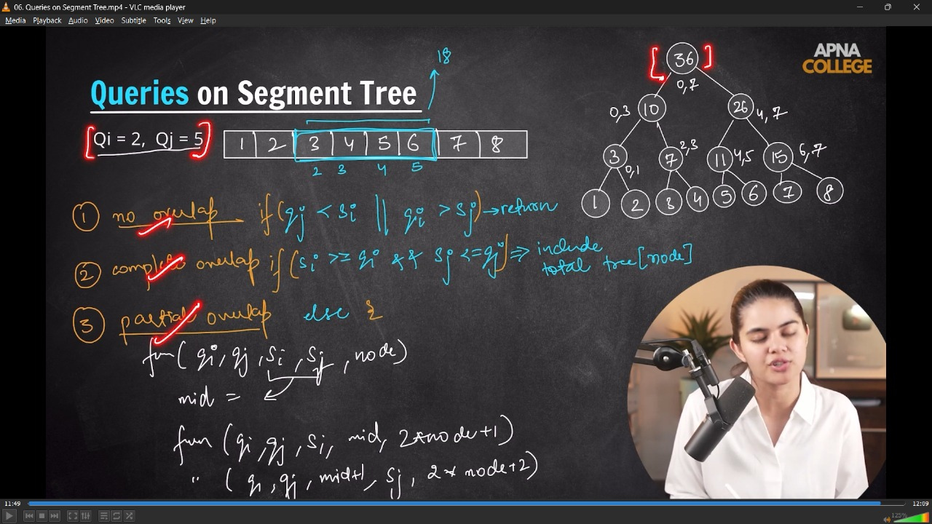
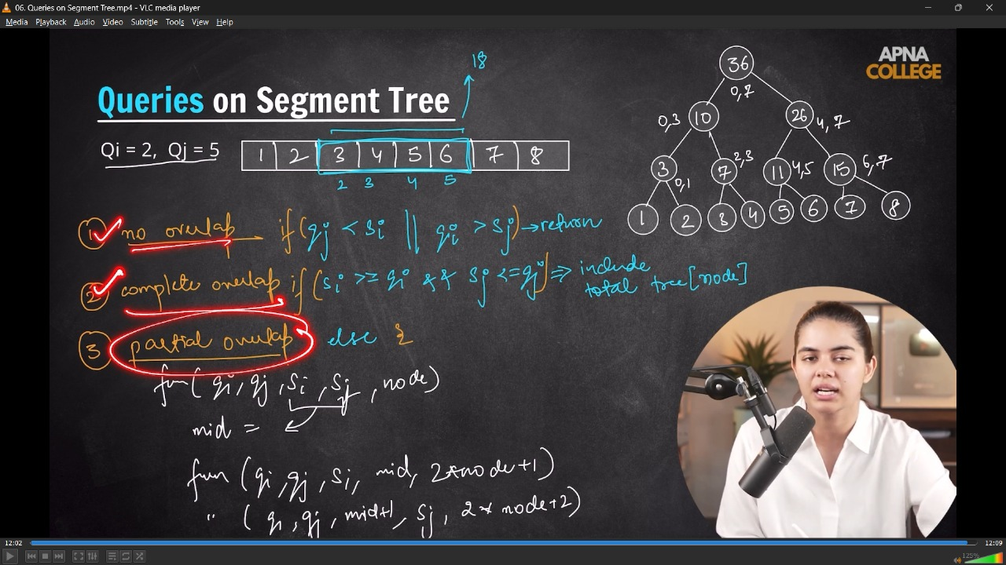
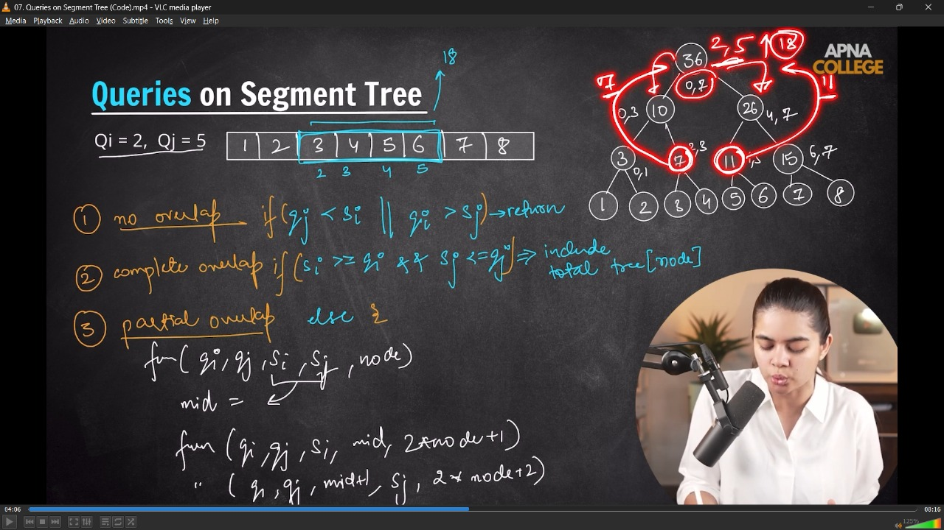
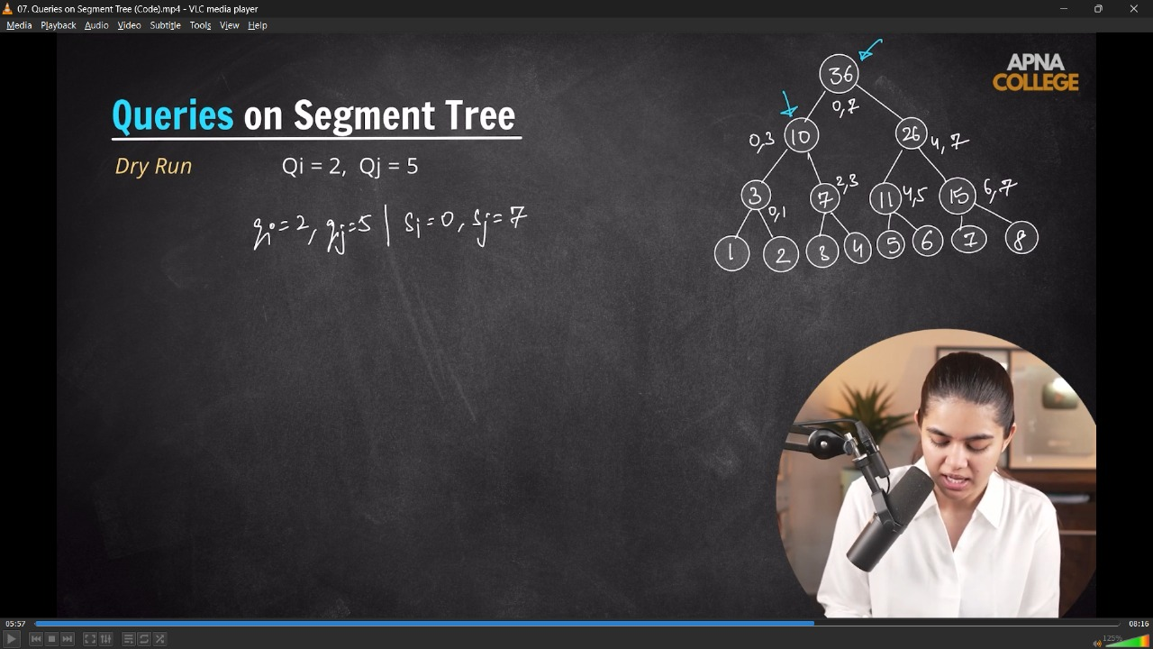
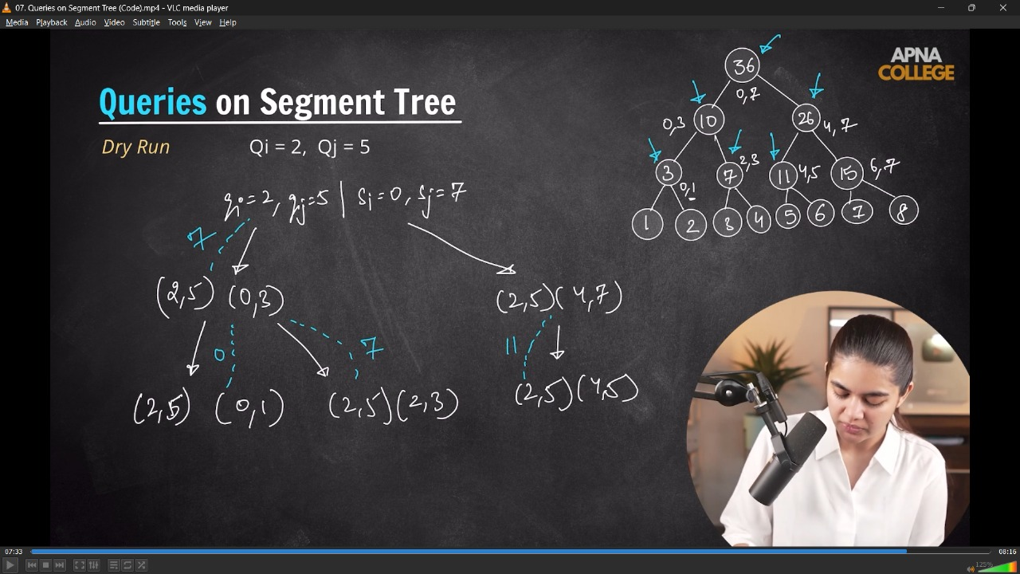
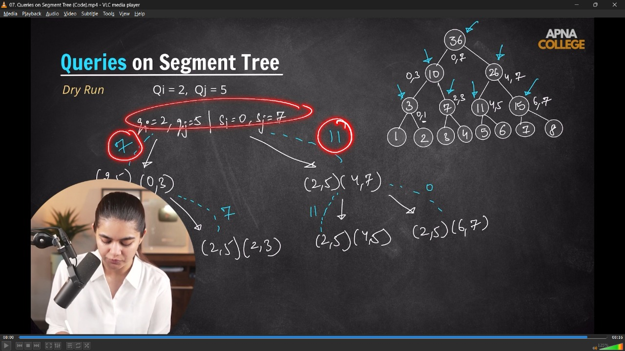
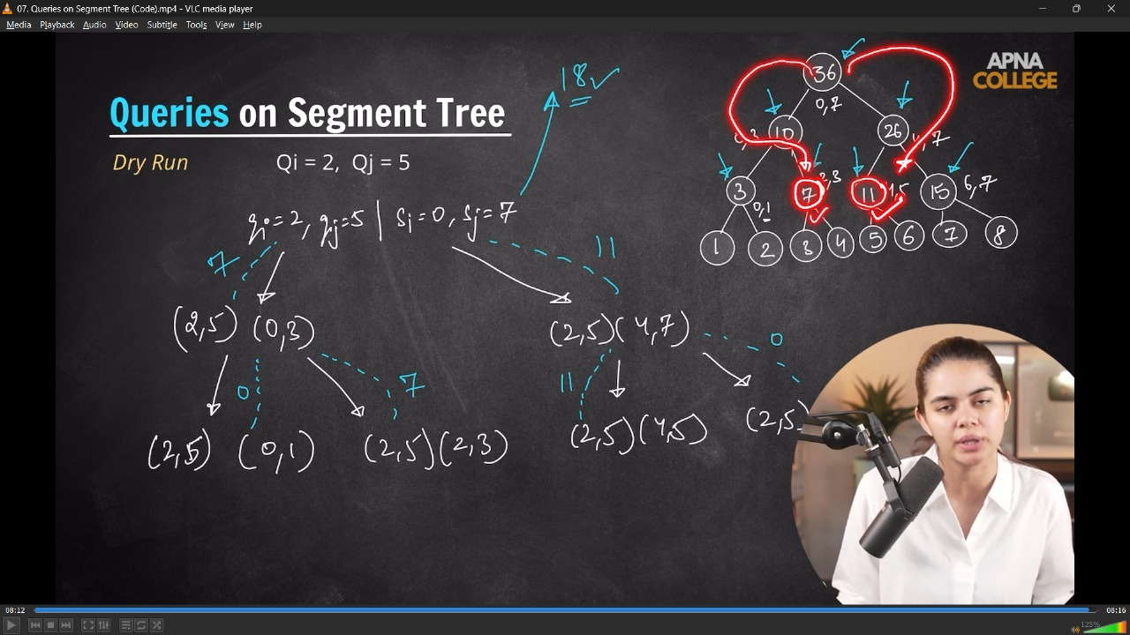
// class SegmentTree
// {
// vector<int> tree; // 4*n
// int n;

// void buildTree(vector<int> &arr, int start, int end, int node) // TC - O(n), Nodes - 2n-1;
// {
// if (start == end)
// {
// tree[node] = arr[start];
// return;
// }
// int mid = start + (end - start) / 2;

// buildTree(arr, start, mid, 2 * node + 1);
// buildTree(arr, mid + 1, end, 2 * node + 2);

// tree[node] = tree[2 * node + 1] + tree[2 * node + 2];
// }

// int rangeSum(int qi, int qj, int si, int sj, int node) // O(log n)
// {
// if (qj < si || qi > sj) // No Overlape
// {
// return 0;
// }
// if (si >= qi && sj <= qj) // Completr Overlap Case
// {
// return tree[node];
// }

// // Partial Overlap
// int mid = si + (sj - si) / 2;

// return rangeSum(qi, qj, si, mid, 2 * node + 1) + rangeSum(qi, qj, mid + 1, sj, 2 * node + 2);
// }

// public:
// SegmentTree(vector<int> &arr)
// {
// n = arr.size();
// tree.resize(4 * n);
// buildTree(arr, 0, n - 1, 0);
// }

// void printTree()
// {
// for (int i = 0; i < tree.size(); i++)
// {
// cout << tree[i] << " ";
// }
// cout << endl;
// }

// int rangeQuery(int qi, int qj)
// {
// return rangeSum(qi, qj, 0, n - 1, 0);
// }
// };

// int main()
// {
// // Range Sum Queries -
// vector<int> arr = {1, 2, 3, 4, 5, 6, 7, 8};

// SegmentTree st(arr);

// cout << st.rangeQuery(2, 5) << endl;//18
// cout << st.rangeQuery(0, 3) << endl;//10
// cout << st.rangeQuery(6, 7) << endl;//15
// cout << st.rangeQuery(3, 6) << endl;//22
// }
// ____________ ____________ ____________ ____________ ____________
3) Update on any index in Segment Tree –

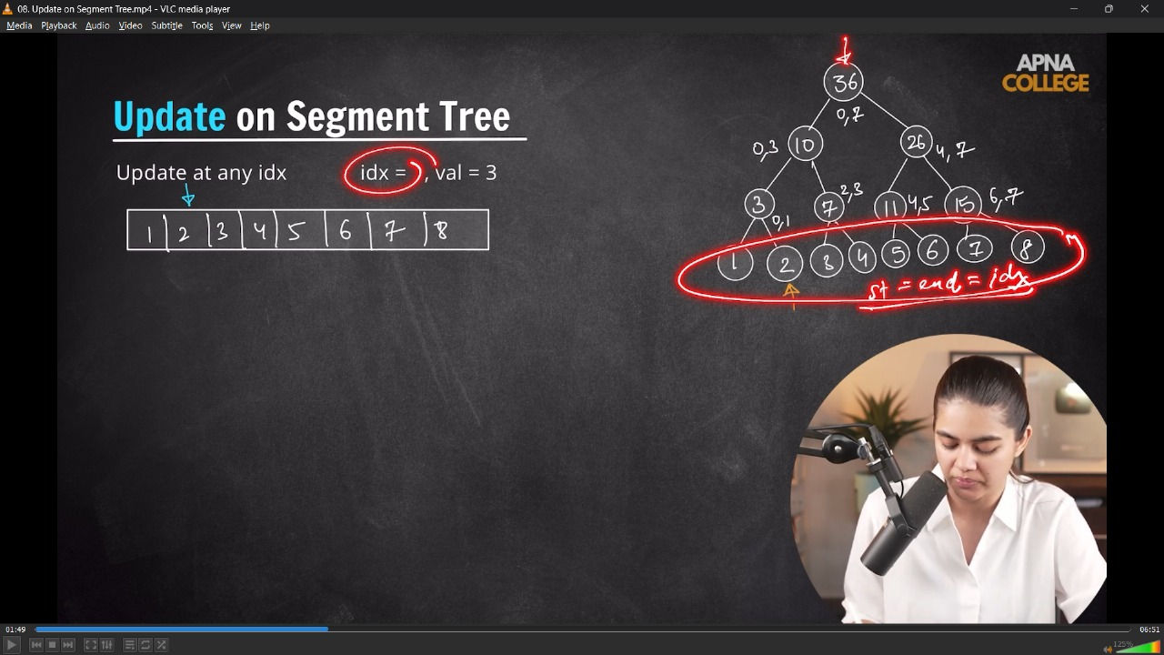
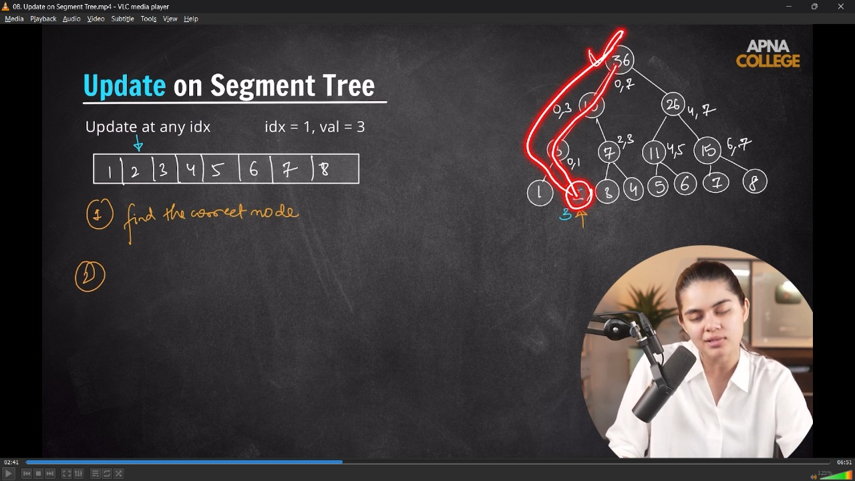


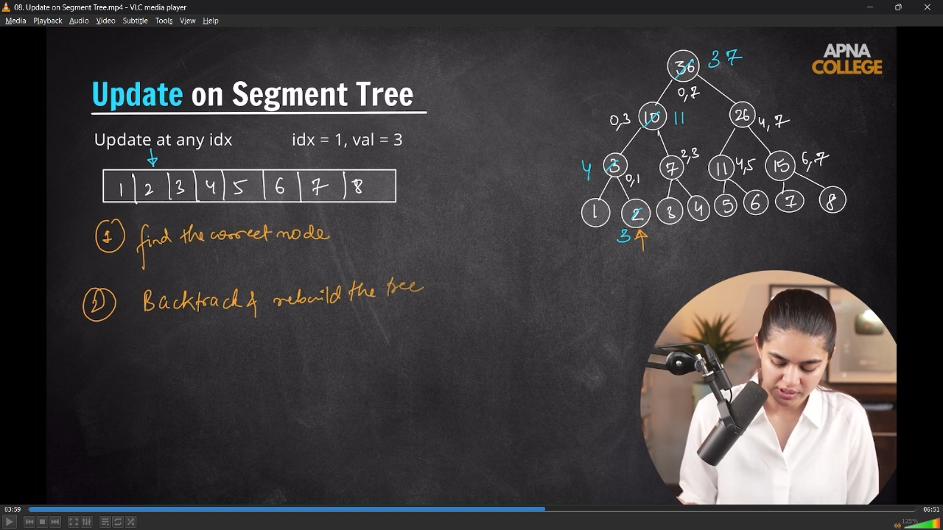
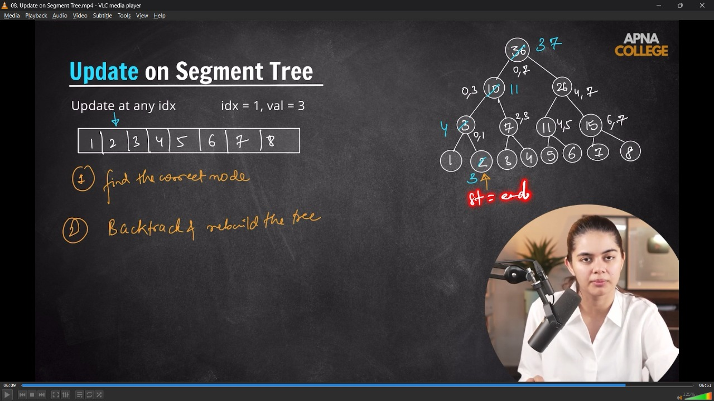
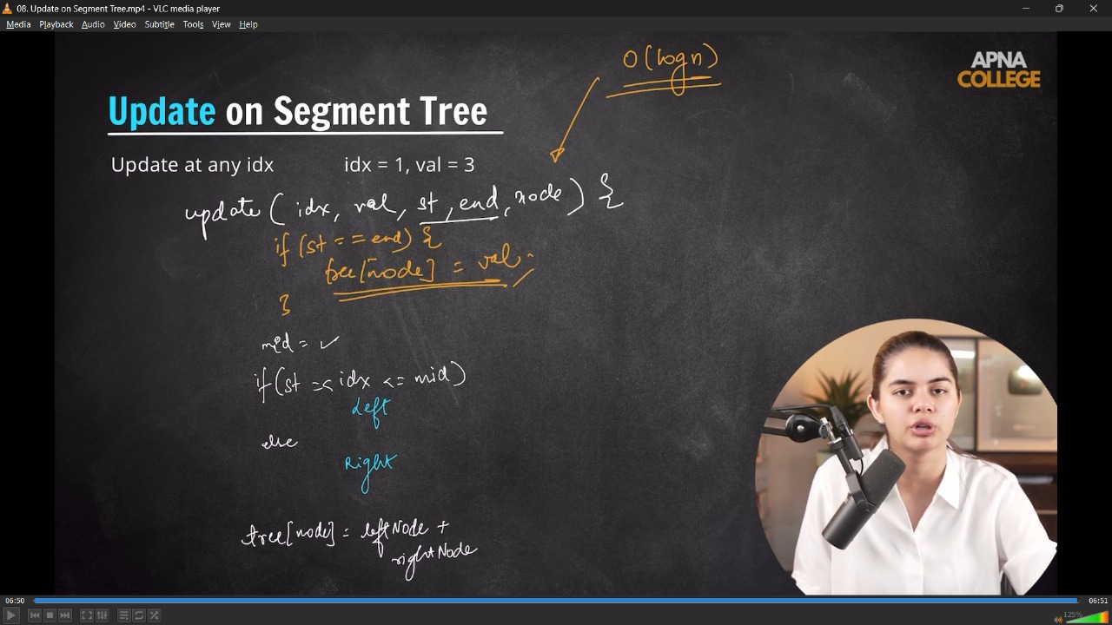

// class SegmentTree
// {
// vector<int> tree; // 4*n
// int n;

// void buildTree(vector<int> &arr, int start, int end, int node) // TC - O(n), Nodes - 2n-1;
// {
// if (start == end)
// {
// tree[node] = arr[start];
// return;
// }
// int mid = start + (end - start) / 2;

// buildTree(arr, start, mid, 2 * node + 1);
// buildTree(arr, mid + 1, end, 2 * node + 2);

// tree[node] = tree[2 * node + 1] + tree[2 * node + 2];
// }

// int rangeSum(int qi, int qj, int si, int sj, int node) // O(log n)
// {
// if (qj < si || qi > sj) // No Overlape
// {
// return 0;
// }
// if (si >= qi && sj <= qj) // Completr Overlap Case
// {
// return tree[node];
// }

// // Partial Overlap
// int mid = si + (sj - si) / 2;

// return rangeSum(qi, qj, si, mid, 2 * node + 1) + rangeSum(qi, qj, mid + 1, sj, 2 * node + 2);
// }

// void updateUtil(int idx, int newVal, int start, int end, int node)
// {
// if (start == end)
// {
// tree[node] = newVal;
// return;
// }
// int mid = start + (end - start) / 2;

// if (idx >= start && idx <= mid) // left
// {
// updateUtil(idx, newVal, start, mid, 2 * node + 1);
// }
// else
// {
// updateUtil(idx, newVal, mid + 1, end, 2 * node + 2);
// }
// tree[node] = tree[2 * node + 1] + tree[2 * node + 2];
// }

// public:
// SegmentTree(vector<int> &arr)
// {
// n = arr.size();
// tree.resize(4 * n);
// buildTree(arr, 0, n - 1, 0);
// }

// void printTree()
// {
// for (int i = 0; i < tree.size(); i++)
// {
// cout << tree[i] << " ";
// }
// cout << endl;
// }

// int rangeQuery(int qi, int qj)
// {
// return rangeSum(qi, qj, 0, n - 1, 0);
// }
// int updateQuery(int idx, int newVal)
// {
// updateUtil(idx, newVal, 0, n - 1, 0);
// }
// };

// int main()
// {
// vector<int> arr = {1, 2, 3, 4, 5, 6, 7, 8};

// SegmentTree st(arr);

// cout << st.rangeQuery(0, 3) << endl; // 10

// st.updateQuery(1,3);
// cout<<st.rangeQuery(0,3)<<endl;//11
// }
// ____________ ____________ ____________ ____________ ____________
4) Max Segment Tree - in particular given range
/*
- Everything is same .. only a little bit change of returning INT_MIN; in Overlapping case. In sum we were returning 0
*/
4.1) Creation & Query in Max Segment Tree -
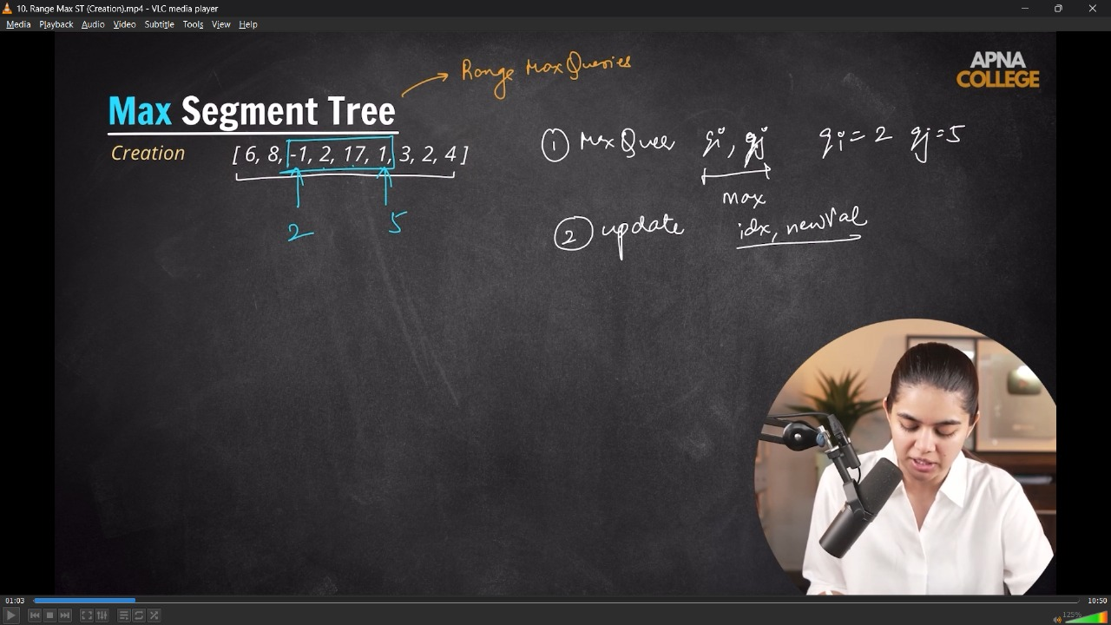
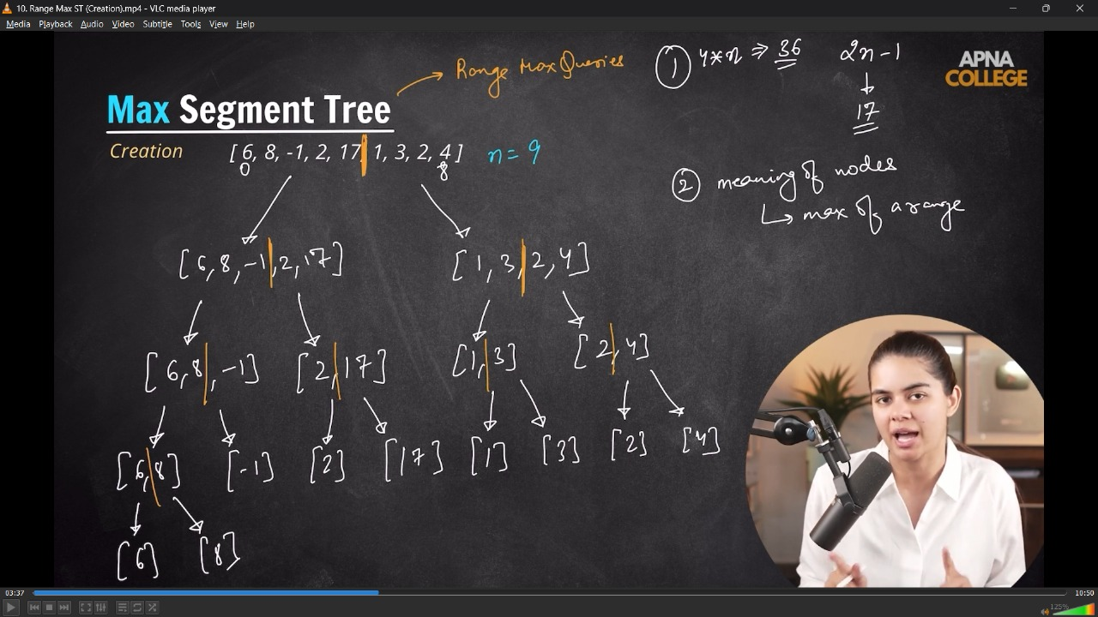
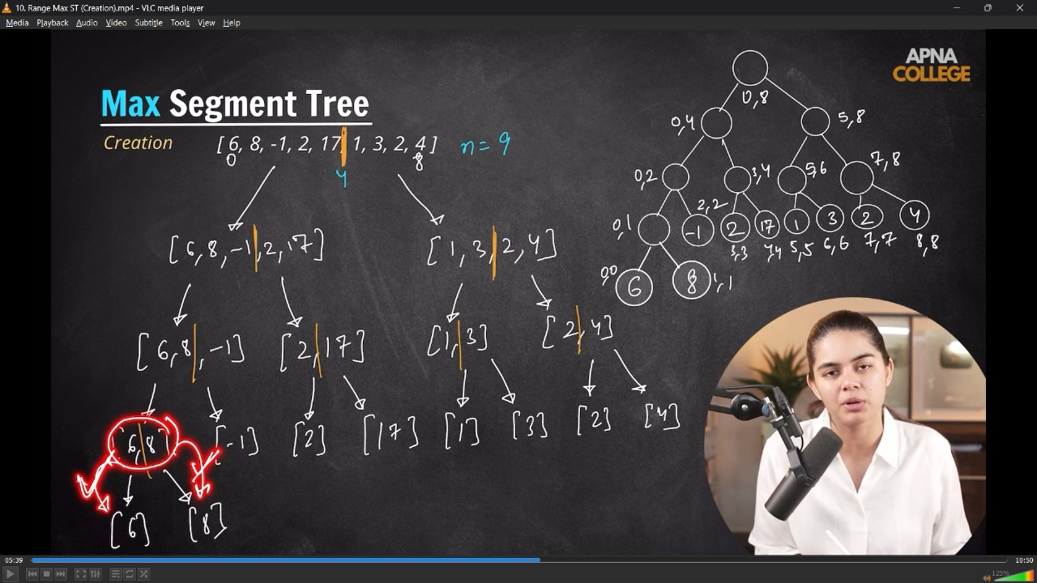
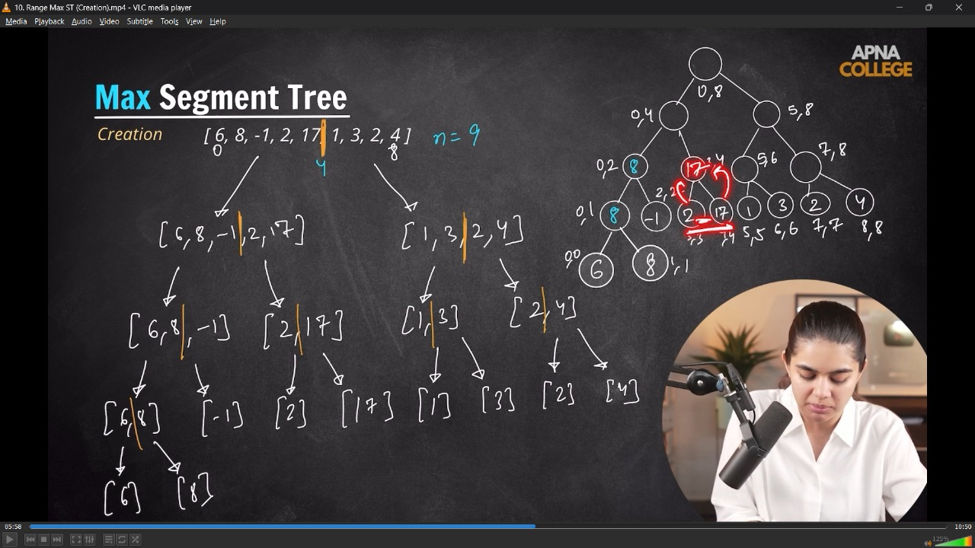
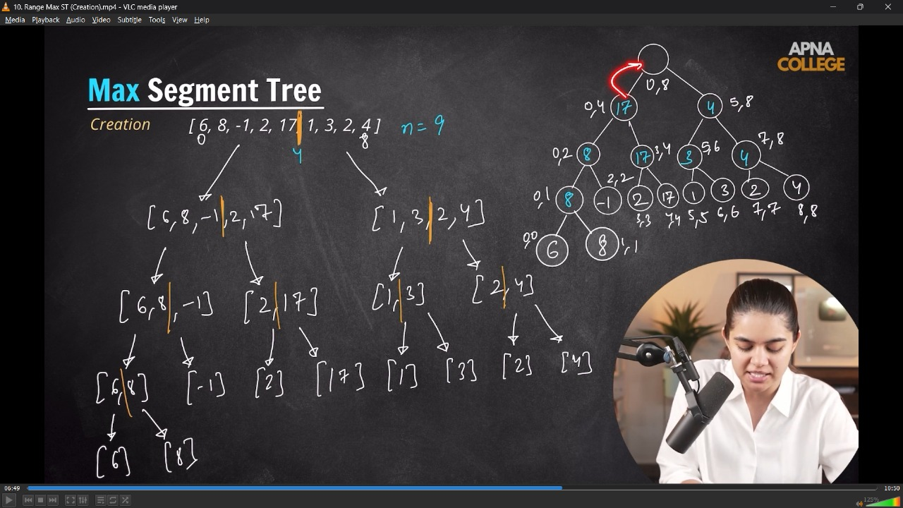
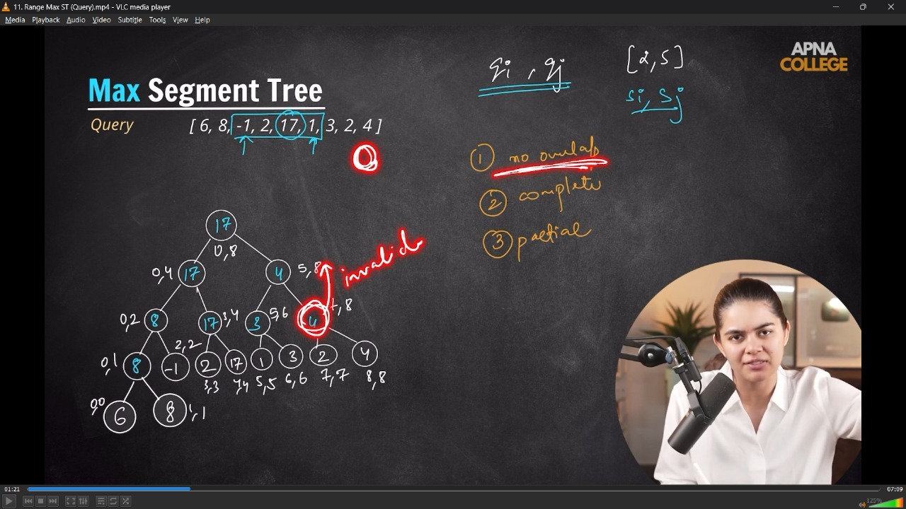
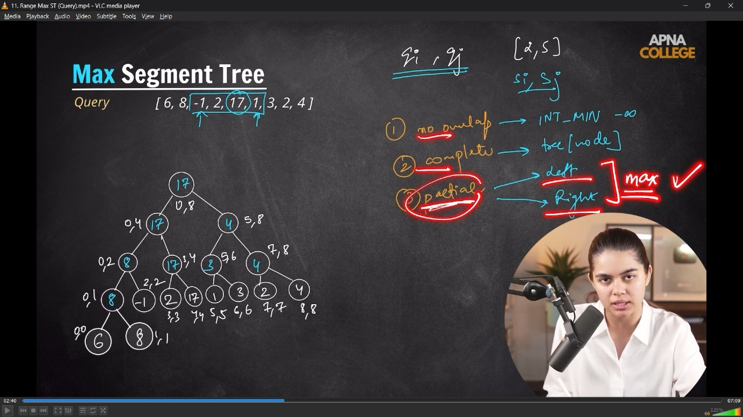
// class SegmentTree
// {
// vector<int> tree;
// int n;

// void buildTree(vector<int> &nums, int start, int end, int node) // O(n)
// {
// if (start == end)
// {
// tree[node] = nums[start];
// return;
// }
// int mid = start + (end - start) / 2;

// buildTree(nums, start, mid, 2 * node + 1);
// buildTree(nums, mid + 1, end, 2 * node + 2);

// tree[node] = max(tree[2 * node + 1], tree[2 * node + 2]);
// }

// public:
// SegmentTree(vector<int> &nums)
// {
// n = nums.size();
// tree.resize(4 * n);
// buildTree(nums, 0, n - 1, 0);
// }

// void printTree()
// {
// for (int i : tree)
// {
// cout << i << " ";
// }
// cout << endl;
// }

// int maxQuery(int qi, int qj, int si, int sj, int node) // O(log n)
// {
// if (qi > sj || qj < si) // No Overlap
// {
// return INT_MIN;
// }
// if (si >= qi && sj <= qj) // completely Iveralp
// {
// return tree[node];
// }
// // partial Overlap case -
// int mid = si + (sj - si) / 2;

// int leftMax = maxQuery(qi, qj, si, mid, 2 * node + 1);
// int rightMax = maxQuery(qi, qj, mid + 1, sj, 2 * node + 2);

// return max(leftMax, rightMax);
// }

// int rangeQuery(int qi, int qj)
// {
// return maxQuery(qi, qj, 0, n - 1, 0);
// }
// };

// int main()
// {
// vector<int> nums = {6, 8, -1, 2, 17, 1, 3, 2, 4};

// SegmentTree st(nums);
// st.printTree();
// // 17 17 4 8 17 3 4 8 -1 2 17 1 3 2 4 6 8 0 0 0 0 0 0 0 0 0 0 0 0 0 0 0 0 0 0 0

// cout << st.rangeQuery(2, 5) << endl; // 17 - Maximum value in the given range/indexing
// cout << st.rangeQuery(5, 8) << endl; // 4
// }
// ____________ ____________
4.2) Update in Range Max Segment Tree - in particular given range : -
/*
- After updating the max in parent-child will get affected/updated and then return accordingly
- The updation operation is almost similar, the only difference of returning max, instead of adding them.
*/
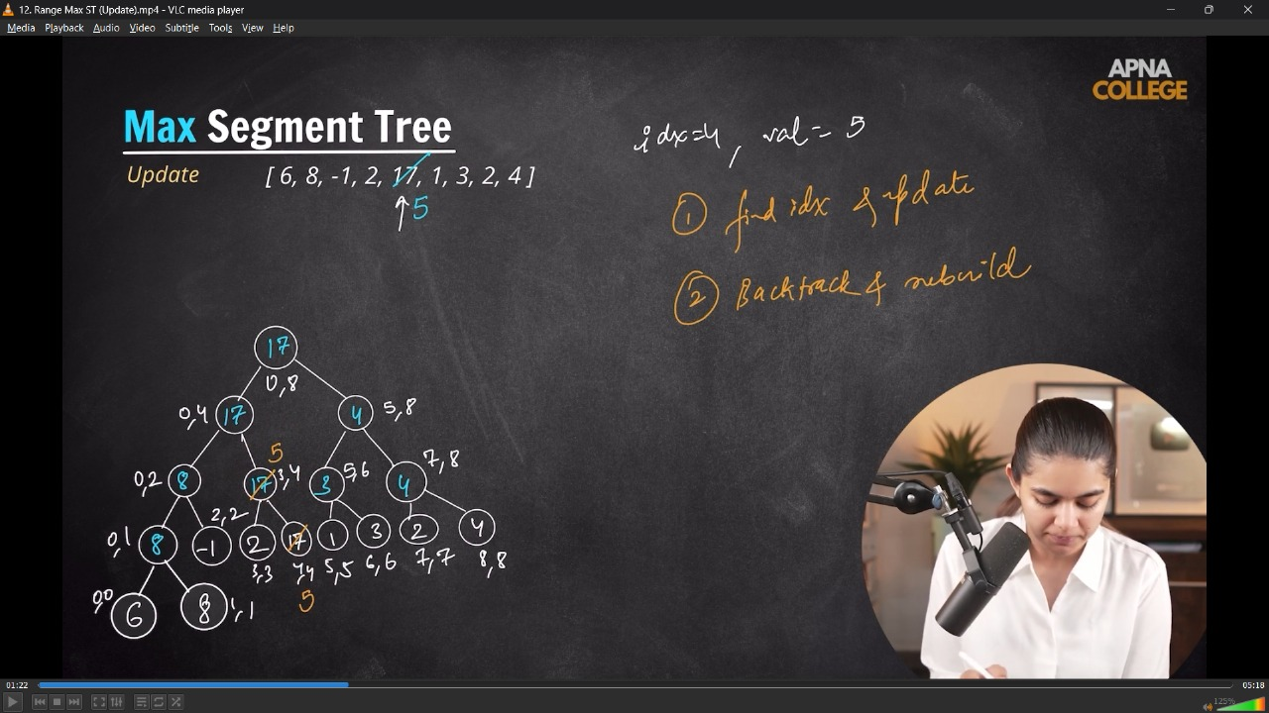
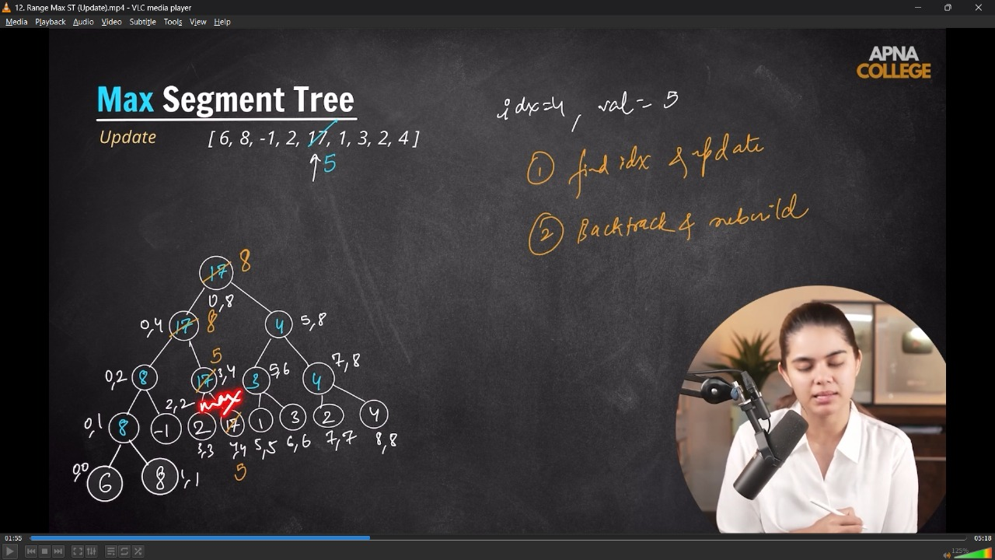
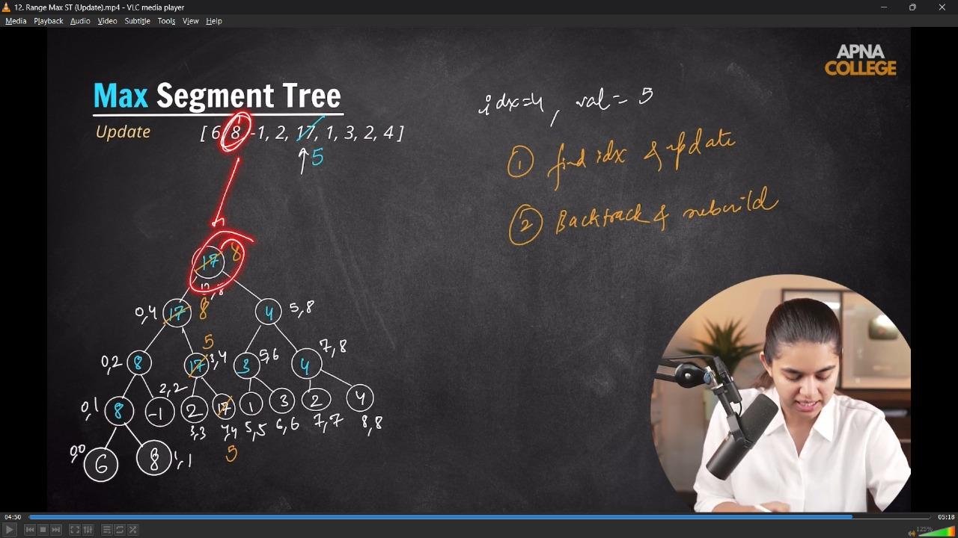
// class SegmentTree
// {
// vector<int> tree;
// int n;

// void buildTree(vector<int> &nums, int start, int end, int node) // O(n)
// {
// if (start == end)
// {
// tree[node] = nums[start];
// return;
// }
// int mid = start + (end - start) / 2;

// buildTree(nums, start, mid, 2 * node + 1);
// buildTree(nums, mid + 1, end, 2 * node + 2);

// tree[node] = max(tree[2 * node + 1], tree[2 * node + 2]);
// }

// void updateUtil(int idx, int newVal, int start, int end, int node) // O(log n)
// {
// if (start == end)
// {
// tree[node] = newVal;
// return;
// }
// int mid = start + (end - start) / 2;

// if (idx >= start && idx <= mid) // Left
// {
// updateUtil(idx, newVal, start, mid, 2 * node + 1);
// }
// else
// {
// updateUtil(idx, newVal, mid + 1, end, 2 * node + 2);
// }
// tree[node] = max(tree[2 * node + 1], tree[2 * node + 2]);
// }

// public:
// SegmentTree(vector<int> &nums)
// {
// n = nums.size();
// tree.resize(4 * n);
// buildTree(nums, 0, n - 1, 0);
// }

// void printTree()
// {
// for (int i : tree)
// {
// cout << i << " ";
// }
// cout << endl;
// }

// int maxQuery(int qi, int qj, int si, int sj, int node) // O(log n)
// {
// if (qi > sj || qj < si) // No Overlap
// {
// return INT_MIN;
// }
// if (si >= qi && sj <= qj) // completely Iveralp
// {
// return tree[node];
// }
// // partial Overlap case -
// int mid = si + (sj - si) / 2;

// int leftMax = maxQuery(qi, qj, si, mid, 2 * node + 1);
// int rightMax = maxQuery(qi, qj, mid + 1, sj, 2 * node + 2);

// return max(leftMax, rightMax);
// }

// int rangeQuery(int qi, int qj)
// {
// return maxQuery(qi, qj, 0, n - 1, 0);
// }

// void updateQuery(int idx, int newVal)
// {
// updateUtil(idx, newVal, 0, n - 1, 0);
// }
// };

// int main()
// {
// vector<int> nums = {6, 8, -1, 2, 17, 1, 3, 2, 4};

// SegmentTree st(nums);
// st.printTree();
// // 17 17 4 8 17 3 4 8 -1 2 17 1 3 2 4 6 8 0 0 0 0 0 0 0 0 0 0 0 0 0 0 0 0 0 0 0

// cout << st.rangeQuery(2, 5) << endl; // 17
// cout << st.rangeQuery(5, 8) << endl; // 4

// st.updateQuery(4, 5);
// cout << st.rangeQuery(0, 8) << endl; // 8
// st.printTree();
// // 8 8 4 8 5 3 4 8 -1 2 5 1 3 2 4 6 8 0 0 0 0 0 0 0 0 0 0 0 0 0 0 0 0 0 0 0
// }
// ____________ ____________ ____________ ____________ ____________
5) Range Min Segment Tree - Creation, Query & Update in particular given range : -

class SegmentTree
{
vector<int> tree;
int n;

void buildTree(vector<int> &nums, int start, int end, int node) // O(n)
{
if (start == end)
{
tree[node] = nums[start];
return;
}
int mid = start + (end - start) / 2;

buildTree(nums, start, mid, 2 * node + 1);
buildTree(nums, mid + 1, end, 2 * node + 2);

tree[node] = max(tree[2 * node + 1], tree[2 * node + 2]);
}

void updateUtil(int idx, int newVal, int start, int end, int node) // O(log n)
{
if (start == end)
{
tree[node] = newVal;
return;
}
int mid = start + (end - start) / 2;

if (idx >= start && idx <= mid) // Left
{
updateUtil(idx, newVal, start, mid, 2 * node + 1);
}
else
{
updateUtil(idx, newVal, mid + 1, end, 2 * node + 2);
}
tree[node] = min(tree[2 * node + 1], tree[2 * node + 2]);
}

public:
SegmentTree(vector<int> &nums)
{
n = nums.size();
tree.resize(4 * n);
buildTree(nums, 0, n - 1, 0);
}

void printTree()
{
for (int i : tree)
{
cout << i << " ";
}
cout << endl;
}

int minQuery(int qi, int qj, int si, int sj, int node) // O(log n)
{
if (qi > sj || qj < si) // No Overlap
{
return INT_MAX;
}
if (si >= qi && sj <= qj) // completely Iveralp
{
return tree[node];
}
// partial Overlap case -
int mid = si + (sj - si) / 2;

int leftMin = minQuery(qi, qj, si, mid, 2 * node + 1);
int rightMin = minQuery(qi, qj, mid + 1, sj, 2 * node + 2);

return min(leftMin, rightMin);
}

int rangeQuery(int qi, int qj)
{
return minQuery(qi, qj, 0, n - 1, 0);
}

void updateQuery(int idx, int newVal)
{
updateUtil(idx, newVal, 0, n - 1, 0);
}
};

int main()
{
vector<int> nums = {6, 8, -1, 2, 17, 1, 3, 2, 4};

SegmentTree st(nums);
st.printTree();
// 17 17 4 8 17 3 4 8 -1 2 17 1 3 2 4 6 8 0 0 0 0 0 0 0 0 0 0 0 0 0 0 0 0 0 0 0

cout << st.rangeQuery(2, 5) << endl;//-1
cout << st.rangeQuery(5, 8) << endl;//4

st.updateQuery(4, 5);
cout << st.rangeQuery(0, 8) << endl;//2
st.printTree();
//2 2 4 8 2 3 4 8 -1 2 5 1 3 2 4 6 8 0 0 0 0 0 0 0 0 0 0 0 0 0 0 0 0 0 0 0
}
// ____________ ____________ ____________ ____________ ____________ ____________ ____________ ____________ ____________ ____________ ____________

